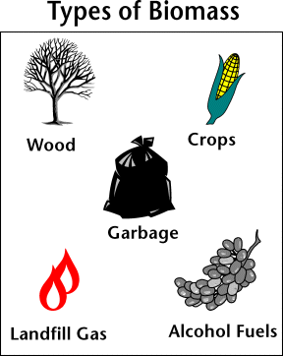**BIOMASS**

Biomass energy is created by **burning organic material made from plants and animals** (microorganisms). Biomass contains stored energy from the sun. Plants absorb the sun’s energy in a process called photosynthesis. The chemical energy in plants gets passed on to animals and people that eat them.

Biomass is a **renewable energy** source because we can always grow more trees and crops, and waste will always exist. Some examples of biomass fuels are wood, crops, manure, and some garbage.

When burned, the chemical energy in biomass is released as heat. If you have a fireplace, the wood you burn in it is a biomass fuel. Wood waste or garbage can be burned to produce steam for making electricity, or to provide heat to industries and homes.

An advantage of biomass, in addition to being a renewable resource, is that it **does not use fossil fuels such as coal or natural gas**. Also it **can release less air pollution**, especially when burning wood for energy. In addition, by burning garbage and other waste, it **reduces the trash that much be buried in landfills**.

However, a disadvantage is that the burning of certain biomass products **can** **actually result in *more* air pollution**. Also, the ash created after burning plants or animal waste **can** **be difficult to properly dispose**.

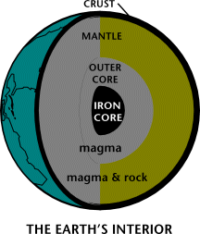**GEOTHERMAL**

The word geothermal comes from the Greek words *geo (*Earth) and *therme* (heat). So, geothermal energy is **heat from within the Earth, generated by Earth’s core**. We can recover this heat as steam or hot water and use it to heat buildings and generate electricity.

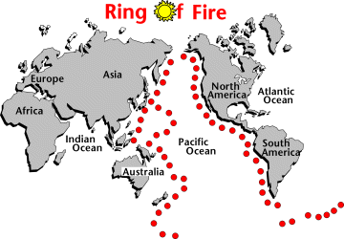Geothermal is a **renewable energy** because the heat is continuously produced inside the Earth.

Naturally occurring areas of hydrothermal resources are called **geothermal reservoirs**. Most geothermal reservoirs are found around the active plate boundary known as the **Ring of Fire**.

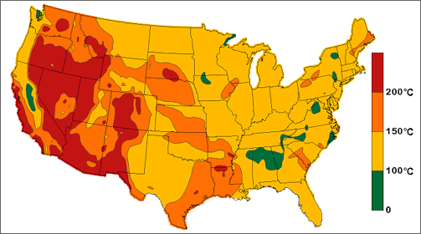

Figure 1: U.S. Geothermal Reservoirs Map

In the United States, most geothermal reservoirs are found in the west.

Some advantages of geothermal energy are that it saves a significant amount of money, it **reduces reliance on fossil fuels,** and helps reduce global warming and air pollution.

Some disadvantages are that the equipment to harness geothermal energy is **not** **widespread**, sometimes hard to find, and can be **expensive to install**. Also, overtime, **geothermal reservoirs can run out of steam** and extensive research must be conducted before drilling and installing the equipment, and only select regions are suitable for successful energy fuel. Lastly, geothermal sites **may also release poisonous gases** found deep within the Earth.

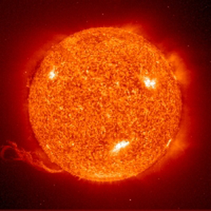**SOLAR**

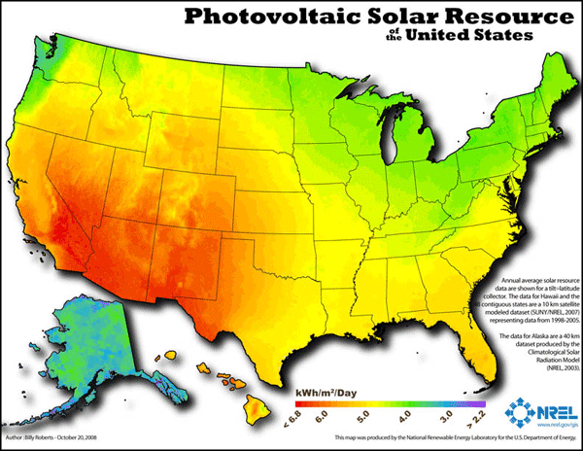The sun has produced energy for billions of years. Solar energy is **produced by capturing the sun’s rays (solar radiation) that reach the Earth and converting it into other forms of energy**, such as heat and electricity. Photovoltaic cells (“solar cells”) change the sunlight directly into electricity. These are found grouped on panels

Because the sun is constantly radiating energy to Earth, solar energy is a **renewable energy**. California has nine solar power plants, the biggest solar power plants in the world!

The main advantage of solar energy is that solar energy systems **do not produce air pollutants or carbon dioxide**, having a minimal impact on the environment. Also, the fuel for solar energy (the sun’s radiation) is **free**!

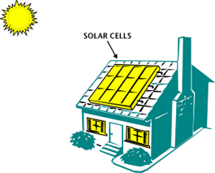  
Some limitations and disadvantages of solar energy is that the amount of sunlight arriving onto Earth’s surface is not constant. It varies depending on location, time of day, time of year, or weather conditions (cloud coverage). Also, because the sun doesn’t deliver that much energy to any one place at any one time, a large surface area is required to install a solar panel large enough to collect enough energy to be useful. Although the sun’s energy is free, the solar panels are currently very expensive to install.

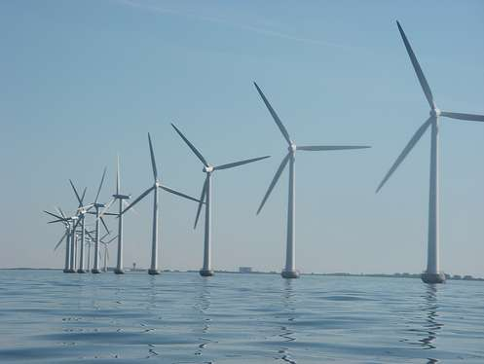**WIND**

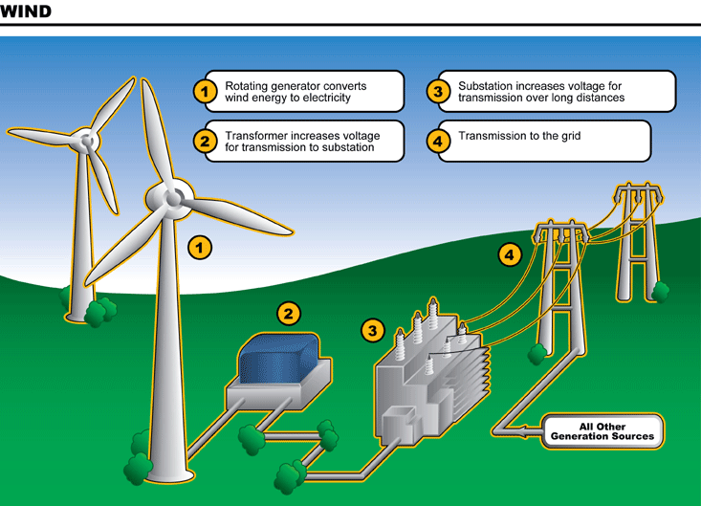The **unequal heating of the earth's surface by the sun produces wind energy, which can be converted into mechanical and electrical energy**. Wind is not a new energy source. People have used it for centuries to power sailing ships and windmills for grinding grains.

Today windmills can be connected to electric generators to turn the wind's motion energy into electrical energy, and wind over 8 miles per hour can be used to generate electricity. It is a **renewable**, but unpredictable, energy source.

According to one estimate, if just the winds of North and South Dakota could be harnessed, they could provide 80 percent of the electrical energy used in the United States!

A disadvantage to wind power is that the wind is often unpredictable and must be a certain speed for sufficient energy to be harnessed. Also, because the wind turbines are so large, some don’t like their visual impact on the landscape. However, a major advantage is that it is a very clean source of energy, and it overall has less negative environmental impacts than many other sources and reduces air pollution.

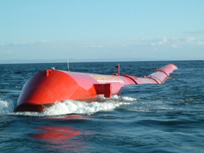**WAVE POWER (Hydroelectric)**

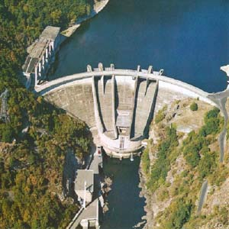Hydro (“*water*”) power is the **renewable energy** source that produces the most electricity in the United States. When water is collected behind dams on large rivers, it provides a source of energy for the production of electricity. The **enormous power of falling water is capable of turning giant turbines, which drive the generators to produce electricity**. The degree of power is determined by the amount of water and the distance it falls.

Waves in particular are caused by the wind blowing over the surface of the ocean, and there is tremendous energy in these waves. The major disadvantage to using Wave Power is that it is not easy to harness this energy and convert it into electricity, thus wave power stations are rare.

An advantage to using hydropower and wave energy is that it **produces clean electricity** with **no waste or pollution**. Although dams are expensive to build, once built, the electricity is virtually free!

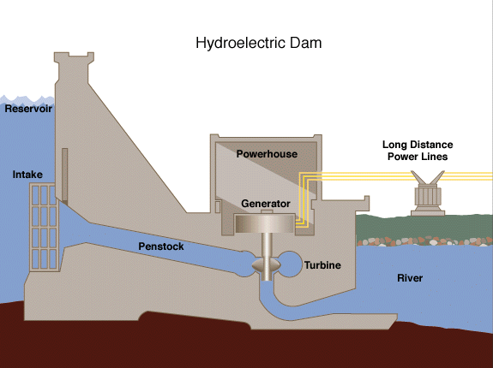Although water power is a renewable resource, **hydroelectric dams have limited lifetimes** and will stop working over a few decades. The **availability of suitable sites to build dams** is another disadvantage. A good site must have a good rate of water flow and provide significant height for water to fall. Most of the best US sites for dams have already been developed. This **limits the use of hydroelectric power in the future**.

**NATURAL GAS**

Sometimes natural gas is confused with gasoline, the fuel in cars. They are not the same. Gasoline is a mixture of liquids, and natural gas is mainly **methane** and is piped into homes and office buildings where it is **used as energy source for heating, cooking washing, and drying**.

The main ingredient in natural gas is **methane** gas. Millions of years ago, the **remains of plants and animals decayed and built up in thick layers**.  Over time, the sand and silt changed to rock, covered the organic material, and trapped it beneath the rock.  Pressure and heat changed some of this organic material into coal, some into oil (petroleum), and some into natural gas — tiny bubbles of odorless gas.

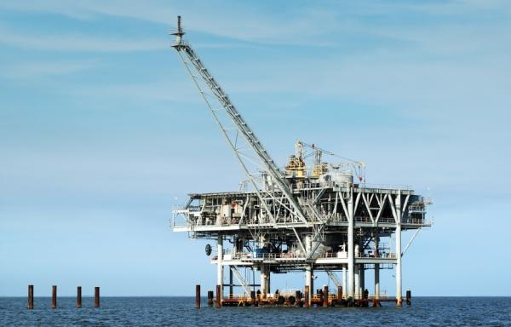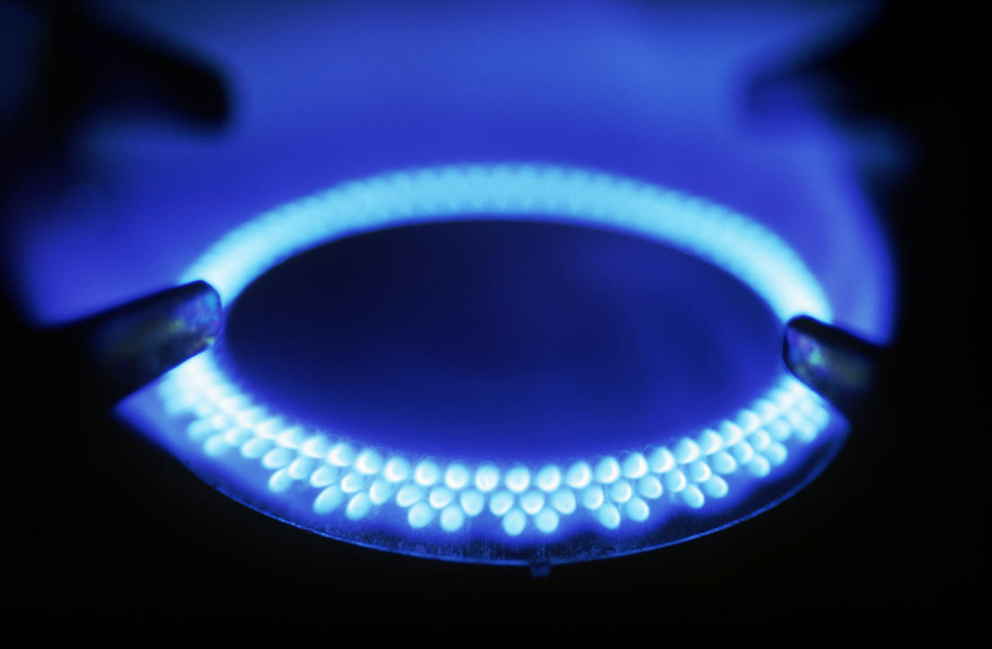One [disadvantage of natural gas](http://www.buzzle.com/articles/what-are-the-disadvantages-of-natural-gas.html) is that it’s a **nonrenewable** **energy** resource. Its availability is finite (limited). Critics also point that their extraction, or removal from the earth, **leaves out large craters within the earth and can harm ecosystems**. It is **highly volatile** (highly flammable) and can be dangerous, if handled carelessly

Natural gas has its advantages. It is a raw material to make other chemicals, and is the **cleanest burning fossil fuel**. This means it **contributes little environmental pollutants** when bummed. Additionally, it **can be safely stored**.

**PETROLEUM/OIL**

Oil was **formed from the remains of animals and plants** **that lived millions of years** ago in a marine (water) environment before the dinosaurs. Over millions of years, the remains of these animals and plants were covered by layers of sand and silt. Heat and pressure from these layers helped the remains turn into what we today call crude oil. The word "petroleum" means "**rock oil**" or "**oil from the earth."**  Because it takes millions of years to form, it is considered a **nonrenewable resource.**

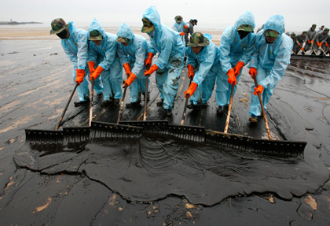This is the black, thick liquid pumped from below the earth's surface wherever you see an oil rig. To make it useful, it is refined. Refining separates the gasoline portion which is used in transportation. Products from the remaining portions include synthetic rubber, detergents, fertilizers, textiles, paints, and pharmaceuticals.

Its advantages are its **usefulness in making many of these products**. Also, it’s **easier to get out** of the ground than coal, making it **cheaper to transport**.

Oil is a carbon based fuel and the primary way it is used is to burn it, **releasing large amounts of carbon dioxide** (CO2) because of the added oxygen. CO2 is a greenhouse gas and is expected by most scientists to be a cause of global warming. Additionally, **we are running out**. Estimates vary from 50 to 150 years before we run out of oil. This is impossible to predict, but most major oil companies have been **failing to discover new reserves** equal to the amount of oil they are producing for the last few years. Finally, **wars are fought over oil**, and wars are won with oil (WWII) so it can be a very **negative influence on relations between nations.**

**COAL**

Coal is the **most abundant fossil fuel**. It is not a widely used energy source due to the cost of mining and its impurities, which cause pollution (acid rain).

Coal **forms from heat and pressure transforming plant material over millions of years**. Coal passes through four stages of development, and as coal develops it becomes harder and releases more heat when burned.

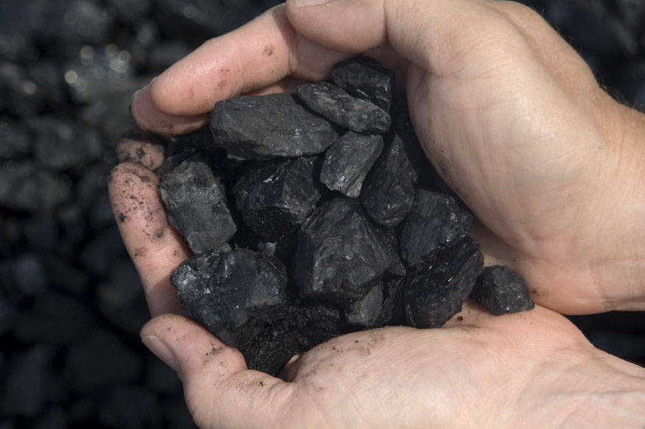

There are two ways to mine coal; underground mining and strip mining. Disadvantage to these methods is the **environmental damage** caused in the process. Also, it **releases the most carbon dioxide** into the environment than any other fuel type.

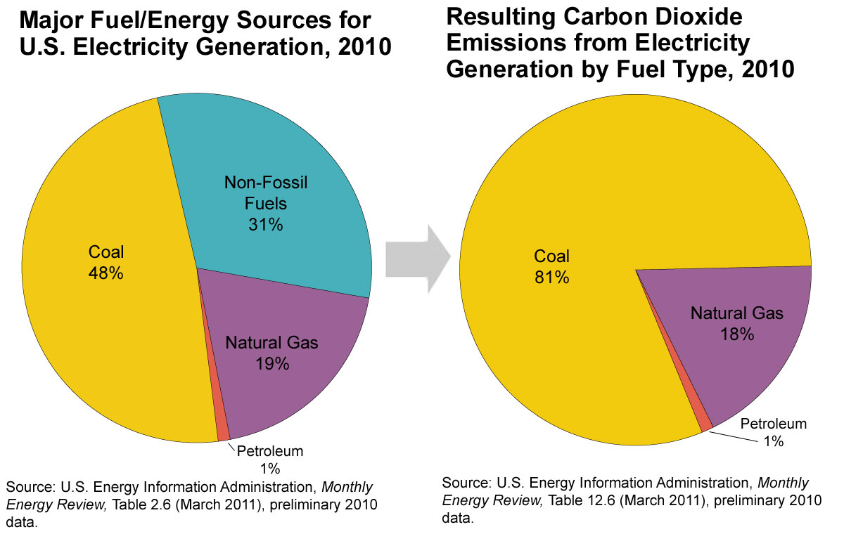An advantage to coal is that it is an **abundant fuel** that is **relatively inexpensive** to produce and convert to useful energy.

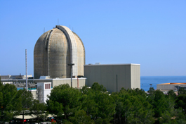**NUCLEAR FISSION**

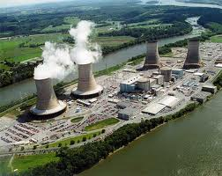Nuclear fission is the **splitting of the uranium atom**, which releases a tremendous amount of heat energy. (This knowledge was used to make atomic bombs.) The fuel for nuclear plants comes from radioactive materials that release energy through nuclear fission. During nuclear fission, a small particle called a neutron (in the nucleus of the uranium atom) hits the uranium atom and splits it, releasing a great amount of energy as heat and radiation. More neutrons are also released. These neutrons go on to bombard and split other uranium atoms, and the process repeats itself over and over again in a chain reaction.

Uranium must be mined and is a nonrenewable energy source.

Today, power companies use the heat produced by nuclear fission to produce electricity. Some people think nuclear energy should be our main source of future energy. Other people feel that the dangers are too great from radioactive waste products, meltdowns, and radiation exposure of workers.

Advantages of nuclear energy is that although it’s nonrenewable, it **does not produce air pollution or carbon dioxide**. Also, relatively little fuel (uranium) is needed to produce very ***large*** amounts of energy.

However, a disadvantage is that constructing nuclear power plants is **extremely expensive**. **Radioactive waste** is a huge concern with nuclear reactors, especially since the Chernobyl accident and the Fukushima Nuclear meltdown in Japan last year. The radiation can have harmful health effects on humans and the environment, and therefore some people feel it’s too dangerous to use.