Biome Posters for Gallery Walk
For this project you will be assigned to a group. Each group will be assigned one of the biomes below. The number of the Biome corresponds to the group # that will be completing that Biome. Each member of your group is responsible for recording your poster information on the note sheet on the next page as well as your peers’ poster information.
1. Arctic Tundra
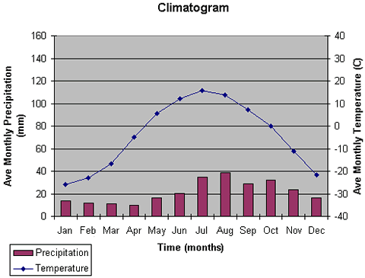
2. Taiga/Boreal Forest/Coniferous Forest
3. Tropical Rainforest
4. Temperate Deciduous (Seasonal) Forest
5. Temperate Grassland/Woodland/Shrubland
6. Tropical Grassland/Savanna
7. Desert
8. Marine/Deep Ocean
9. Freshwater (Rivers, swamps, lakes)

Each group will create a poster about one of the Biomes.
- Each poster must include the following:
- Average monthly Temperature (range)
- Average monthly Precipitation (Rainfall)
- Include a Climatogram for your Biome. The Climatogram includes average rainfall and precipitation by month. (There is a diagram above). (Try to get a climatogram that is uses Celsius for Temperature and milimeters for rainfall.)
- Type of Soil and what the Soil Profile looks like. What are some reasons why the soil profile looks the way it does.
- Limiting Factors in the Biome (What prevents growth in the Biome?) - How do some animals or plants overcome these limiting factors?
- Physical Features of the Biome
- Other Abiotic Factors - amount of sunlight, air pressure, etc.
- Dominant Plants - at least 3 - try to draw a picture (Include Adaptations each plant has to thrive in this biome)
- Dominant Animals - at least 3 - try to draw a picture (Include Adaptation each plant has to thrive in this biome)
- Where are they located (Geographic Distribution) – Include a Map (try to draw this) - Latitude Range is needed for this map and general location.
- Unique Characteristics (Example: Forest Structures for the Temperate Rain & Seasonal and the Tropical Rainforest - FIND AT LEAST ONE FOR YOUR BIOME)
- Hazards the Biome is facing?
- Is anything being done to help the biome? Laws/Regulation, etc.
Biome Name: ___________________________________
- Draw the climatogram of this biome on the graph to the right.

- What is the Annual Temperature and Precipitation of this biome?

- Soil Profile/Type of Soil (Draw a diagram below)

- Highlight the Geographic Locations of the Biome on the map below.
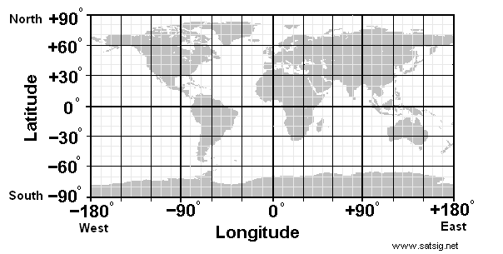

- Name at least 3 animals in this biome: (List the adaptations that make them successful in this biome)

- Name at least 3 plants in this biome (List the adaptations that make them successful in this biome)

- What are some limiting factors in this biome?
- Unique Characteristics of the Biome
- Hazards the Biome is facing
10. Laws or regulation protecting or pertaining to the biome? Name and brief explanation.
Biome Name: ___________________________________
1. Draw the climatogram of this biome on the graph to the right.
2. What is the Annual Temperature and Precipitation of this biome?

- Soil Profile/Type of Soil (Draw a diagram below)

- Highlight the Geographic Locations of the Biome on the map below.

- Name at least 3 animals in this biome: (List the adaptations that make them successful in this biome)

- Name at least 3 plants in this biome (List the adaptations that make them successful in this biome)

- What are some limiting factors in this biome?
- Unique Characteristics of the Biome
- Hazards the Biome is facing
- Laws or regulation protecting or pertaining to the biome? Name and brief explanation.
Biome Name: ___________________________________
- Draw the climatogram of this biome on the graph to the right.

- What is the Annual Temperature and Precipitation of this biome?

- Soil Profile/Type of Soil (Draw a diagram below)

- Highlight the Geographic Locations of the Biome on the map below.

- Name at least 3 animals in this biome: (List the adaptations that make them successful in this biome)

- Name at least 3 plants in this biome (List the adaptations that make them successful in this biome)

- What are some limiting factors in this biome?
- Unique Characteristics of the Biome
- Hazards the Biome is facing
10. Laws or regulation protecting or pertaining to the biome? Name and brief explanation.
Biome Name: ___________________________________
- Draw the climatogram of this biome on the graph to the right.

- What is the Annual Temperature and Precipitation of this biome?

- Soil Profile/Type of Soil (Draw a diagram below)

- Highlight the Geographic Locations of the Biome on the map below.

- Name at least 3 animals in this biome: (List the adaptations that make them successful in this biome)

- Name at least 3 plants in this biome (List the adaptations that make them successful in this biome)

- What are some limiting factors in this biome?
- Unique Characteristics of the Biome
- Hazards the Biome is facing
- Laws or regulation protecting or pertaining to the biome? Name and brief explanation.
Biome Name: ___________________________________
- Draw the climatogram of this biome on the graph to the right.

- What is the Annual Temperature and Precipitation of this biome?

- Soil Profile/Type of Soil (Draw a diagram below)

- Highlight the Geographic Locations of the Biome on the map below.

- Name at least 3 animals in this biome: (List the adaptations that make them successful in this biome)

- Name at least 3 plants in this biome (List the adaptations that make them successful in this biome)

- What are some limiting factors in this biome?
- Unique Characteristics of the Biome
- Hazards the Biome is facing
10. Laws or regulation protecting or pertaining to the biome? Name and brief explanation.
Biome Name: ___________________________________
- Draw the climatogram of this biome on the graph to the right.

- What is the Annual Temperature and Precipitation of this biome?

- Soil Profile/Type of Soil (Draw a diagram below)

- Highlight the Geographic Locations of the Biome on the map below.

- Name at least 3 animals in this biome: (List the adaptations that make them successful in this biome)

- Name at least 3 plants in this biome (List the adaptations that make them successful in this biome)

- What are some limiting factors in this biome?
- Unique Characteristics of the Biome
- Hazards the Biome is facing
10. Laws or regulation protecting or pertaining to the biome? Name and brief explanation.
Biome Name: ___________________________________
- Draw the climatogram of this biome on the graph to the right.

- What is the Annual Temperature and Precipitation of this biome?

- Soil Profile/Type of Soil (Draw a diagram below)

- Highlight the Geographic Locations of the Biome on the map below.

- Name at least 3 animals in this biome: (List the adaptations that make them successful in this biome)

- Name at least 3 plants in this biome (List the adaptations that make them successful in this biome)

- What are some limiting factors in this biome?
- Unique Characteristics of the Biome
- Hazards the Biome is facing
10. Laws or regulation protecting or pertaining to the biome? Name and brief explanation.
Biome Name: ___________________________________
- Draw the climatogram of this biome on the graph to the right.

- What is the Annual Temperature and Precipitation of this biome?

- Soil Profile/Type of Soil (Draw a diagram below)

- Highlight the Geographic Locations of the Biome on the map below.

- Name at least 3 animals in this biome: (List the adaptations that make them successful in this biome)

- Name at least 3 plants in this biome (List the adaptations that make them successful in this biome)

- What are some limiting factors in this biome?
- Unique Characteristics of the Biome
- Hazards the Biome is facing
10. Laws or regulation protecting or pertaining to the biome? Name and brief explanation.
Biome Name: ___________________________________
- Draw the climatogram of this biome on the graph to the right.

- What is the Annual Temperature and Precipitation of this biome?

- Soil Profile/Type of Soil (Draw a diagram below)

- Highlight the Geographic Locations of the Biome on the map below.

- Name at least 3 animals in this biome: (List the adaptations that make them successful in this biome)

- Name at least 3 plants in this biome (List the adaptations that make them successful in this biome)

- What are some limiting factors in this biome?
- Unique Characteristics of the Biome
- Hazards the Biome is facing
10. Laws or regulation protecting or pertaining to the biome? Name and brief explanation.

