Practice #5: Analyzing a Cladogram
U6-20
Directions: Use the cladogram below to answer the following questions.
- What characteristic (speciation event) separates the salamander from the lizard?

- What characteristic (derived character / speciation event) differentiates the hagfish from the perch?

- Which two species are most closely related?
  - Perch and salamander
  - Lizard and chimp
  - Hagfish and chimp
  - Salamander and pigeon
- Which trait evolved first?
  - Feathers
  - Lungs
  - Jaws
  - Fur
- Evolutionarily, which species is oldest?
  - Mouse
  - Pigeon
  - Salamander
  - Perch
- According to the cladogram, which animal is most closely related to the mouse?
A. Salamander B. Perch C. Lizard D. Chimp

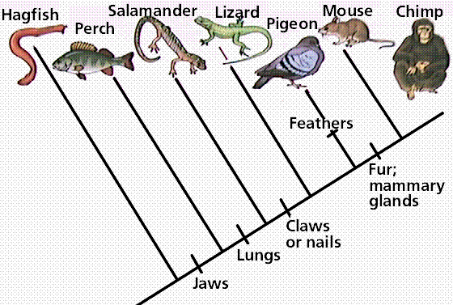

Examine the sample cladogram, each letter on the diagram points to a derived character, or something different (or newer) than what was seen in previous groups. Match the letter to its character.
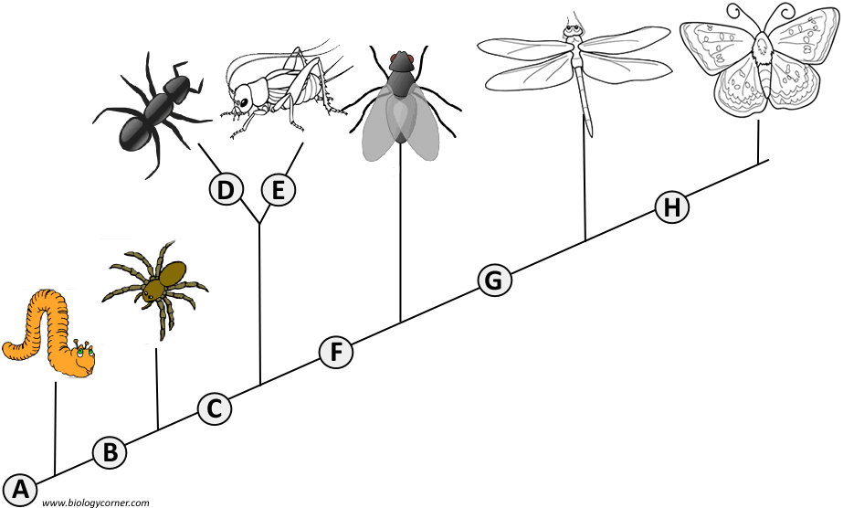
1. ______ Wings
2. ______ 6 Legs
3. ______ Segmented Body
4. ______ Double set of wings
5. ______ Jumping Legs
6. ______ Crushing mouthparts
7. ______ Legs
8. ______ Curly Antennae

