**Unit 6: Evolution & Classification Review**

**Name**: __________________________

1. Classifying Using Keys: Practice with Dichotomous Keys

**Directions:** Use the Fishy Dichotomous Key. Choose **6 fish**, place the letter of the fish in the table and classify each based on the Fishy Dichotomous Key, record the name of the fish in the table.

|  |  |  |  |  |  |
| --- | --- | --- | --- | --- | --- |
| **Letter** | **Name** | **Letter** | **Name** | **Letter** | **Name** |
|  |  |  |  |  |  |
|  |  |  |  |  |  |

2. Evolutionary Evidence: Understanding the Evidence of Evolution and Interpreting Evolutionary Relationships

**Part III** Directions: Refer to the Biochemical Evidence Sheet. Answer the following questions.

**DNA comparison**

1. You are looking at DNA sequences in 3 primates. What can it tell us? ____________________________________________________________________________________________________
2. Which two organisms have the most DNA in common? ___________________________
3. Which two organisms share a common ancestor? _________________________

**Part IV** Directions: Refer to the Anatomical Evidence Sheet. Answer the following questions.

**Homologous Structures**

1. What does the prefix “homo” mean? __________________
2. Which structures are most closely related? ______________________________
3. What do you think you can determine based on these bones? ________________________________________
4. Based on the structures you see, which organisms are evolutionarily most related? _____________________

**Vestigial Structures**

1. What is a vestigial structure? ________________________________________________________________________
2. What is the vestigial structure on the whale? ___________________________
3. Name one vestigial structure in humans. _______________________________

**Part V** Directions: Refer to the Fossil Evidence Sheet. Answer the following questions

**Fossil Layers**

1. Write the number of the organism that is most primitive (oldest): ________
2. Write the number of the organism that probably evolved first: ________
3. Which organisms are more closely related those at levels 1 and 2 or those at levels 4 and 7? _________

3. Classification Systems

**Part I** Directions: Use the **Classification Systems Sheet** to answer the questions below.

1. Who is responsible for the foundation of our 7 level classification system that we use today? ______________________
2. What are the 7 levels of classification?
3. Which level of classification includes the most organisms? __________________
4. Which level of classification includes the least organisms? __________________
5. Which level of classification contains organisms that have the most similar DNA? ___________________
6. Which two levels of classification are used in scientific naming? _____________________ & _______________

**Part II** Directions: Use the **5 Kingdoms Sheet** to answer the questions below.

1. Complete the chart below by recording the characteristics found on the reference sheet.

|  |  |  |  |  |
| --- | --- | --- | --- | --- |
| **Bacteria** | **Protist** | **Plant** | **Animal** | **Fungi** |
|  |  |  |  |  |

**\*\*Consult pg. U6-15 if you need extra help!\*\***

1. Which of the kingdoms includes prokaryotic organisms? ______________________
2. Which of the kingdoms includes heterotrophic, multicellular organisms with cell walls? ________________
3. Which of the kingdoms includes eukaryotic, autotrophic multicellular organisms? ___________________
4. Which of the kingdoms includes unicellular organisms with organelles? ______________________
5. Which of the kingdoms have chloroplasts (go through photosynthesis = autotrophic)? _________________

4. Early Experiments: Analyzing the Conditions on Early Earth and How Life Began

**Part I** Directions: Refer to the Evolution of Early Organisms Sheet. Put the characteristics I - IV in order to show the evolution of early organisms on earth.

1st:

2nd:

3rd:

4th:

**Part II** Directions: Refer to the Endosymbiotic Theory Reference Sheet. Answer the following questions.

1. Which **organelles** did aerobic bacteria become in primitive eukaryotes? _____________________________
2. Which **organelles** did photosynthetic bacteria become in primitive eukaryotes? ______________________
3. What organisms did aerobic (with mitochondria) eukaryotes give rise to? _____________________________
4. What organisms did primitive photosynthetic (with chloroplasts) eukaryotes evolve into? _____________________________

5. Natural Selection: Analyzing the Mechanisms of Evolution

**Directions**: Refer to the Natural Selection Scenarios Sheet. For each of the scenarios, write the names of the best fit organism on the lines below.

1) ______________________________ 2) ______________________________ 3) ______________________________

4) ______________________________ 5) ______________________________ 6) ______________________________

7) ______________________________ 8) ______________________________ 9) ______________________________

6. Evolution EOC Review: Preparing for the EOC

**Directions**: Refer to the Evolution EOC Review Sheet . Read each question carefully and choose the best answer.

1) ______________________________ 2) ______________________________ 3) ______________________________

4) ______________________________ 5) ______________________________ 6) ______________________________

7) ______________________________ 8) ______________________________ 9) ______________________________

Part 1: Fishy Dichotomous Key

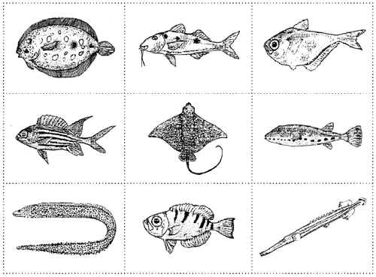

**H**

**G**

**I**

**F**

**E**

**D**

**C**

**B**

**A**

|  |
| --- |
| **Step 1** If fish shape is long and skinny then go to step 2  If fish shape is not long and skinny, then go to step 3 |
| **Step 2** If fish has pointed fins, it is a trumpet fish If fish has smooth fins, it is a spotted moray eel |
| **Step 3** If fish has both eyes on top of the head, then go to step 4 If fish has one eye on each side of the head, then go to step 5 |
| **Step 4** If fish has long whip-like tail, it is a spotted eagle ray If fish has short, blunt tail, it is a peacock flounder |
| **Step 5** If fish has spots, then go to step 6 If fish does not have spots, then go to step 7 |
| **Step 6** If fish has chin "whiskers," it is a spotted goat fish If fish does not have chin "whiskers," it is a band-tail puffer |
| **Step 7** If fish has stripes, then go to step 8 If fish does not have stripes, it is a glassy sweeper |
| **Step 8** If fish has a v-shaped tail, it is a squirrel fish If fish has a blunt tail, it is a glass-eye snapper |

Part 2: Biochemical Evidence Sheet



Fossil Evidence Sheet

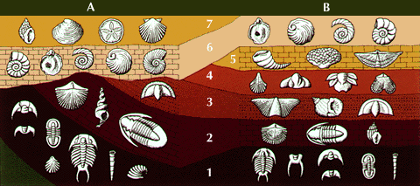

Part 2: Anatomical Evidence Sheet

Homologous structures

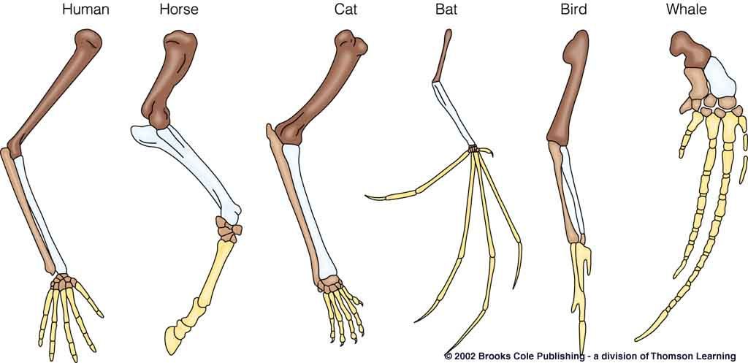

Vestigial structures

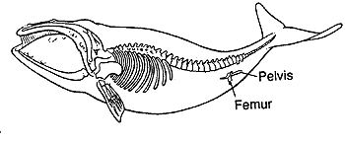

Part 3: Classification Systems Sheet

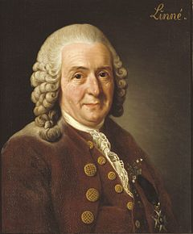

Carl Linnaeus

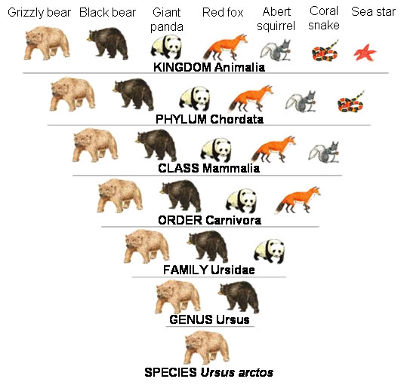

Part 3: 5 Kingdoms Sheet

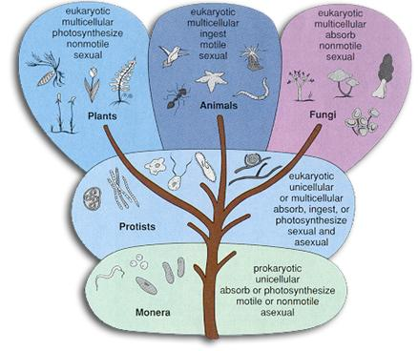

Part 4: Evolution of Early Organisms Reference Sheet

1. Eukaryotic Cells
2. Photosynthetic Prokaryotic Cells
3. Anaerobic Prokaryotic Cells
4. Aerobic Prokaryotic Cells

Part 4: Endosymbiotic Theory Reference Sheet

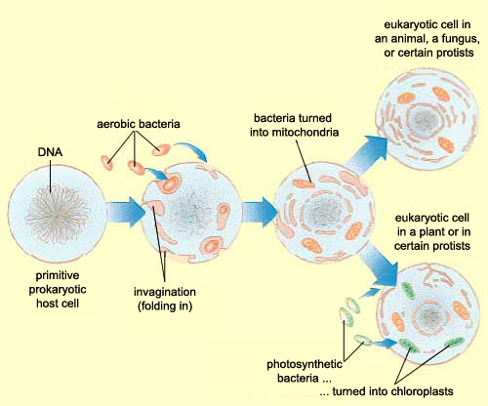

Part 5: Natural Selection Scenario Sheet

**🡪Pick the organism with the best adaptations for the environment!**

1. Giraffes live in a region where all of trees are very tall. Short-necked giraffes or long-necked giraffes?
2. Plants in the rainforest that need sunlight and try to avoid being shaded by other plants. Tall plants or short plants?
3. Antelopes are the prey of very fast cheetahs. Fast antelope or slow antelope.
4. Cheetahs chase their prey in order to capture them for food. Fast cheetahs or slow cheetahs?
5. Tortoises live on an island that contains many short shrubs and bushes that are low to the ground. Short-necked tortoises or long-necked tortoises?
6. Moths live in an environment that contains many light colored trees. Light moths or dark moths?
7. A bird preys on insects that hide in holes in trees. Long-beaked birds or short-beaked bird?
8. Polar bears live in an environment often covered in snow and stalk their prey. Polar bears with white noses or polar bears with dark noses?
9. Moths live an area that is very polluted. Light or dark moths?

Part 6: Evolution EOC Review

**1. The use of pesticides on crops has been a common farming practice for decades. What has been the *greatest* effect of natural selection through the use of pesticides on certain insect populations?**

A. Natural selection has been altered because the insects and their predators are killed.

B. The rate of selection is increased because the pesticides do not kill the insects that are naturally resistant to it.

C. The rate of selection has decreased because the pesticides kill only young insects.

D. The pesticides have altered natural selection by causing the insect DNA to spontaneously mutate.

**2. A large population of cockroaches was sprayed with an insecticide. A few of the cockroaches survived and produced a population of cockroaches that was resistant to this spray. What can *best* be inferred from this example?**

A. A species will adapt no matter what the environment. B. The environment has no effect on the survival of an organism.

C. Insecticides cause mutations that are passed on to the next generation. D. Individuals with favorable variations survive and reproduce.

**3. In which populations does genetic drift most often occur?**

A. in small populations B. in large populations C. in marine populations D. in terrestrial populations

**4. Species A and B share similarities in DNA sequences. What would this suggest about their evolutionary relationship?**

A. Species A developed before species B B. Species A and B share a recent common ancestor.

C. Species A and B are unrelated. D. Species B developed before Species A.

**5. During the Industrial Revolution, there were two variations of English Peppered Moths, those with light color and those with dark color. The soot from the factories covered the trees. Data was collected to measure the percentage of each type of moth in the area. It was noted that the percentage of dark-colored moths increased over time, while the percentage of light-colored moths decreased. What is the likely explanation for this change?**

A. The presence of a mutation changed the color of the English Peppered Moths.

B. The presence of the dark-colored variation increased the likelihood for survival of the English Peppered Moths.

C. The presence of the light-colored variation increased the likelihood for survival of the English Peppered Moths.

D. The presence of an acquired trait changed the color of the English Peppered Moths.

**6. Which types of organisms developed first due to the early environmental conditions on Earth?**

A. prokaryotic and aerobic B. prokaryotic and anaerobic C. eukaryotic and aerobic D. eukaryotic and anaerobic

**7. Darwin’s studies of finches on the Galapagos Islands suggest that the finches' differences in beak structure were most directly due to:**

A. acquired characteristics in the parent finches B. mating behaviors of the different finch species

C. the size of the island where the finches live D. adaptations of the finches to different environments

**8. During extreme conditions like drought or high heat, frogs will dig a hole in the soil and bury themselves. Sometimes frogs will shed a layer of skin, wrap it around themselves for more protection, and wait for rain. How does this adaptation aid frogs?**

A. This adaptation aids in the survival of frogs. B. This adaptation attracts other frogs for mating.

C. This adaptation helps the frog find food. D. This adaptation aids in the growth of frogs.

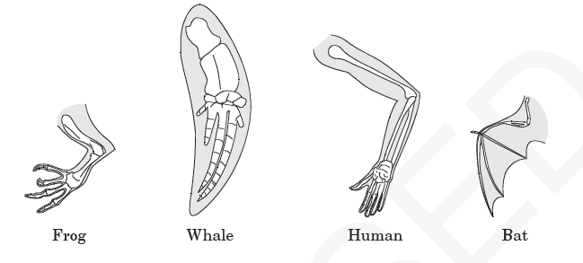**9. What do the similarities of the structures suggest about these organisms?**

A. They grow at the same rate. B. They live in the same environment.

C. They live for the same length of time. D. They evolved from a common ancestor