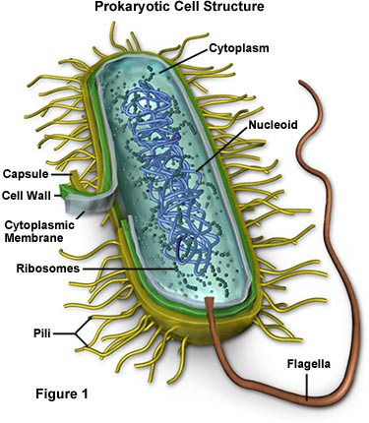
Description of Course
IB/MYP Biology Syllabus
Ms. Simmons
North Mecklenburg High School
Room J204
Email: brooke1.simmons@cms.k12.nc.us
Website: brookesimmonsbio.weebly.com
School Phone: (980) 343-3840
Personal Phone: (704) 313-9126 *no calls after 7pm or on weekends*

Biology is an exciting course that surveys the study of life! We will be investigating many biological questions and will work to discover answers and come up with more unanswered questions. Biology is an EOC class and passing this course is required for graduation! Together, we will make sure you are prepared to ace the exam in June!

Big Goal
Biology is a very important class. Not only do you need to pass this class to graduate, you will also gain an understanding of biology that will help you in college and in your everyday life! My BIG GOAL for you is that all students will average at least an 80% on all biology objectives and that every single one of you will pass the EOC in the spring with a 4 or 5!

Materials Needed
The materials you bring for my class will be used for Biology alone. Required materials must be brought to class every day so that you are prepared for success! Materials must be obtained by Monday, August 31. Please come see me ASAP if materials are not available to you.

Required Materials | Optional Materials/Ms. Simmons’ Wish List
- 1 ½ or 2” binder for biology ONLY | - Colored pencils
- Pens or pencils | - Markers
- 8 binder dividers | - Tissue
- Notebook paper | - Scissors
 | - Hand sanitizer
 | - Ream of copy paper

Classroom Expectations
The expectations outline how you should behave and ensure that everyone in the class is safe and can learn.
- Be on time with all materials and ready to learn
- Respect yourself and others
- Listen to directions the first time
- Always have a positive attitude
- Follow North Mecklenburg High School policies
This includes but is not limited to:

- BYOT (bring your own technology)
Students are encouraged to bring technology to school to use for educational purposes. However, students are ONLY allowed to use technology during days the teacher has explicitly stated that students may use their devices. Unless otherwise stated, electronic devices are NOT permitted for use during the instructional period. No exceptions! Having these devices out is a distraction and hinders learning. If a student is caught using one of these in class when the teacher has prohibited the use of electronic devices, the student will be asked to put it away. If the student refuses or continues to use the device, security will be called and administrators will handle the matter.

- Tardy Policy
Students will have six (6) minutes between classes to get to their next class.
Late students will be documented and further action will be taken for excessive tardies which includes but is not limited to administration referrals, lunch detention, and ISS.

- Late Work Policy
Students are expected to turn all assignments in ON TIME. If a student fails to turn in work the day it is due, he/she may turn in late work. However, as the teacher, I do have the right to deduct points each day the assignment is late.

- Absences
I will update my teacher website weekly with all class assignments, homework, and notes as well as the corresponding PowerPoints. It is the student’s responsibility to find out what was missed and ask questions if he/she needs clarification. If absent, the student is responsible for obtaining all notes as well as turning in any missed work. If work was assigned BEFORE the student was absent, it is due the day he/she returns. If work was assigned DURING the absence, he/she will have 5 days to turn in the make-up work before points will be deducted (see Late Work Policy). It is YOUR responsibility to seek make-up work. If you fail to do so, you will receive a zero for that assignment. Make-up work will not be completed during class time.

Positive Consequences | Negative Consequences
- Positive parent contact | 1. Verbal warning
- Homework pass | 2. Parent contact
- Content mastery and academic success! | 3. Seat change/removal from class to complete independent work
 | 4. Referral to administration
 | ***I reserve the right to call home at any point***
Grade Weights
70% Formal: assessments, mini-assessments, tests, projects
30% Informal: homework, class work, participation

CMS Grading Policy*
A 90-100%
B 80-89%
C 70-79%
D 60-69%
F 59% and below
*please note that CMS has adopted a 10 point grading scale

Biology Units
Unit 1: Course Intro/Scientific Method/STERNGRR | Unit 5: Meiosis and Genetics
Unit 2: Biochemistry | Unit 6: Evolution and Classification
Unit 3: Cells, Transport, Bioenergetics | Unit 7: Ecology and Human Impact
Unit 4: DNA, Mitosis/Protein Synthesis and Biotechnology | EOC Review

IB Mission Statement
The International Baccalaureate aims to develop inquiring, knowledgeable and caring young people who help to create a better and more peaceful world through intercultural understanding and respect. To this end the organization works with schools, governments and international organizations to develop challenging programmes of international education and rigorous assessment. These programmes encourage students across the world to become active, compassionate and lifelong learners who understand that other people, with their differences, can also be right.
IB Academic Honor Policy
Each International Baccalaureate student will use an Honor Statement to reflect his or her commitment to abide by this policy.

I want YOU to succeed! Please come to tutoring and use enrichment effectively!
I am here for YOU!!!
Be proactive about YOUR education and YOUR future!

By signing below, I have read the syllabus and understand the expectations outlined in it.

Student signature: __________________________________ Date: _____________________

Parent signature: ___________________________________ Date: _____________________

