#1

Sweating when hot and an increase in heart rate when exercising are examples of what process?

#2

List the 8 characteristics

of life and give the definitions

#3

What are the subunits AND function of carbohydrates?

#4

What are the subunits AND function of proteins?

#5

What are the subunits AND function

of lipids?

#6

What are the subunits AND function of

nucleic acids?

#7

What are the 4 indicator tests for organic compounds?

List the NAME of the test, WHICH organic compound it tests for, and HOW you know it’s a positive result.

#8

Explain how muscle cells become different than blood cells

#9

List the 5 levels of organization in a cell from smallest to largest

#10

Draw the mitochondria AND give its function

#11

Draw the chloroplast AND give its function

#12

Draw the ribosome AND give its function

# 13

Give 2 facts for BOTH of the following

|  |  |
| --- | --- |
| **Active Transport** | **Passive Transport** |
| 1.  2. | 1.  2. |

#14

What will happen to the cell over time?

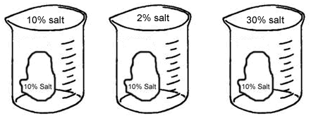

#15

Which direction will the O2 and CO2 move?



#16

* Fill in the table below

|  |  |  |  |  |  |
| --- | --- | --- | --- | --- | --- |
|  | **TYPE** | **MOVES?** | **DIRECTION?** | **USES ENERGY?** | **USES A PROTEIN?** |
| **PASSIVE** | **Diffusion** |  |  |  | **NO** |
| **Osmosis** |  | **_______ to Low** |  | **NO** |
| **Facilitated Diffusion** | **Particles** | **High to ______** |  |  |
| **ACTIVE** | **Active Transport** | **Particles** |  |  |  |

#17

Describe the difference between the following:

* Osmosis
* Diffusion
* Facilitated Diffusion

# 18

Draw the lock and key model and label the following: enzyme, substrate, product, active site

#19

Draw an enzyme graph showing an optimum temperature or pH

#20

Write the reaction for photosynthesis in words AND formulas

#21

Write the reaction for cellular respiration in words AND formulas

#22

What is the difference between aerobic and anaerobic respiration?

#23

List 3 factors that can affect photosynthesis

# 24

What is ATP?

What is ADP?

What is the difference between the two molecules?

#25

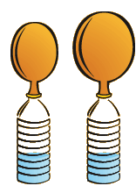

* Name 3 things in the bottle
* What gas is being produced?

#26

Aerobic respiration makes ______ ATP.

Anaerobic respiration makes ______ ATP

#27

What does a biotic factor mean? Give 2 examples

#28

What does an abiotic factor mean? Give 2 examples

#29

List the 4 types of symbiotic relationships?

Who benefits? Who is harmed? Who is unaffected? Give 1 example of EACH kind

#30

Draw a simple food chain linking 4 organisms. Label the producer, primary consumer, secondary consumer, and tertiary consumer.

#31

Describe logistic growth & exponential growth. Sketch a picture of each.

#32

Define carrying capacity. Explain how this number is reached.

#33

What type of growth is the human population?

What will happen if humans continue to grow in population?

#34

What is an invasive species?

How does an invasive species affect an ecosystem?

#35

What is deforestation? What causes it?

How does it impact our environment?

#36

What is climate change?

What causes it?

How does it impact our environment?

#37

What is acid rain? What causes it?

How does it impact our environment?

#38

What is the function of the mitochondria?  How does it do its job? (Through which process?)

#39

What is the function of the chloroplast?  How does it do it’s job (through which process?)

#40

Write the formula for photosynthesis and cellular respiration.  How do they compare?

#41

Where does photosynthesis happen?  Where does cellular respiration happen?

#42

What are 3 differences between aerobic and anaerobic cellular respiration?

#38

List 3 characteristics for each process:

|  |  |
| --- | --- |
| Mitosis | Meiosis |
| 1.  2.  3. | 1.  2.  3. |

#39

List the 6 stages of cell division in order AND describe what is happening in each phase.

#40

Organize the pictures in the PROPER order

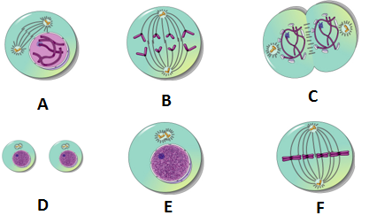

#41

**Mitosis** begins with ___ cell(s) and ends with ___ cells with ____ chromosomes

**Meiosis** begins with ___ cell(s) and ends with ___ cells with ____ chromosomes

#42

The advantage to mitosis is that it is _________.

The disadvantage to mitosis is that ______________________________.

#43

The disadvantage to meiosis is that it is _________.

The advantage to meiosis is that ______________________________.