Name: \_\_\_\_\_\_\_\_\_\_\_\_\_\_\_\_\_\_\_\_\_\_\_\_\_\_\_\_\_\_\_ Block: \_\_\_\_\_\_\_ Date: \_\_\_\_\_\_\_\_\_\_\_\_\_\_\_\_\_\_\_\_\_\_\_\_\_

**The Ultimate Biology Midterm Study Guide**

**Organic Molecules**

**Complete the chart about organic molecules and their monomers.**

|  |  |  |
| --- | --- | --- |
| **Organic Molecule** | **Monomers (subunits)** | **Function** |
| **Carbohydrates**  (starch and simple sugar) |  |  |
| **Lipids**  (fats) |  |  |
| **Proteins** |  |  |
| **Nucleic Acids** |  |  |

1. A positive **Benedict’s** test indicates the presence of a \_\_\_\_\_\_\_\_\_\_\_\_\_\_\_\_\_\_\_\_\_.
2. A positive **iodine** test indicates the presence of a \_\_\_\_\_\_\_\_\_\_\_\_\_\_\_\_\_\_\_\_\_\_\_.
3. A positive **Buiret’s** test indicates the presences a \_\_\_\_\_\_\_\_\_\_\_\_\_\_\_\_\_\_\_\_\_\_.
4. A positive **brown paper bag** test indicates the presence of a \_\_\_\_\_\_\_\_\_\_\_\_\_\_\_\_\_\_\_.
5. Enzymes, hormones, and receptor molecules are all \_\_\_\_\_\_\_\_\_\_\_\_\_\_\_\_\_\_\_, which means they are all compose of **amino acids.**
6. Which two elements are found in all **organic** molecules? Use the very back of the textbook if necessary.
7. Label the following as either **organic (O)** or **inorganic (I).**
   1. Carbon dioxide (CO2) \_\_\_\_\_\_
   2. Oxygen (O2) \_\_\_\_\_
   3. Glucose (C6H12O6) \_\_\_\_\_
   4. Water (H2O) \_\_\_\_\_

**Identify these pictures of organic molecules. Use the textbook if necessary.**

|  |  |  |  |
| --- | --- | --- | --- |
| **Picture** | **Which organic molecule?** | **Picture** | **Which organic molecule?** |
| Description: glucose |  | Description: lkj 007 |  |
|  |  | Description: 120px-ATP_chemical_structure |  |
|  |  |  |  |
|  |  |  |  |

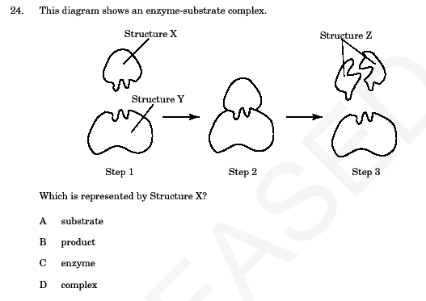**Enzymes**

1. Label the **enzyme** and **substrate** in the picture to the right.
2. Enzymes are what type of organic molecule? What are the subunits (monomers)?
3. Are enzymes **reusable**? What does that mean?

1. How do **pH** and **temperature** alter the activity of an enzyme?
2. What is it called when enzymes’ lose their shape and can no longer work?
3. Pepsin is an enzyme involved in digestion. Use the diagram and graph to the right to answer the following:
   1. In what organ is pepsin located?
   2. What is pepsin’s **optimum pH?**

**Cell Organelles**

**What is the function of the following organelles?**

|  |  |  |
| --- | --- | --- |
| **Cell Part** | **Function** | **found in which cells?**  (plant, animal, or both) |
| Nucleus |  |  |
| Cell Membrane |  |  |
| Cell wall |  |  |
| Mitochondria |  |  |
| Vacuoles |  |  |
| Chloroplasts |  |  |
| Ribosomes |  |  |

**Draw the missing organelles in the animal and plant cells below:**

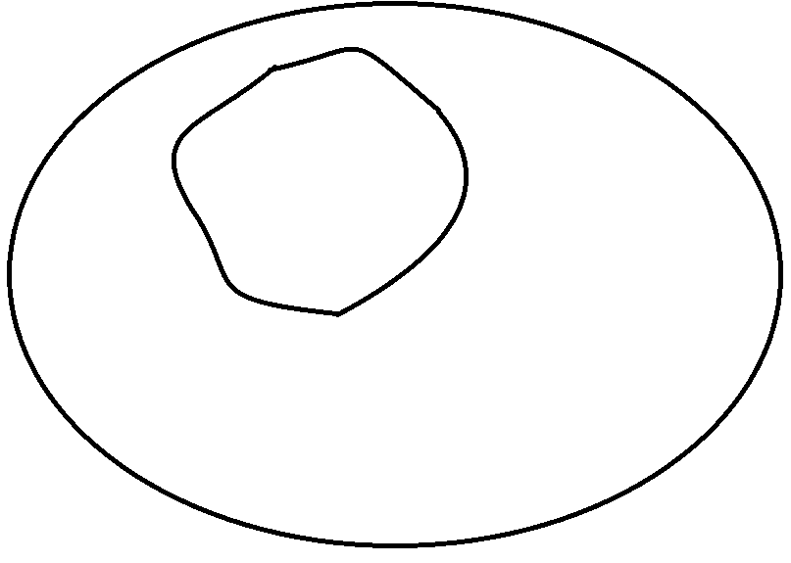

**Draw/label the following in these two cells:**

* DNA
* Cell membrane
* Cell wall
* Vacuole
* Ribosome
* Mitochondria
* Cytoplasm
* Chloroplast
* Endoplasmic reticulum

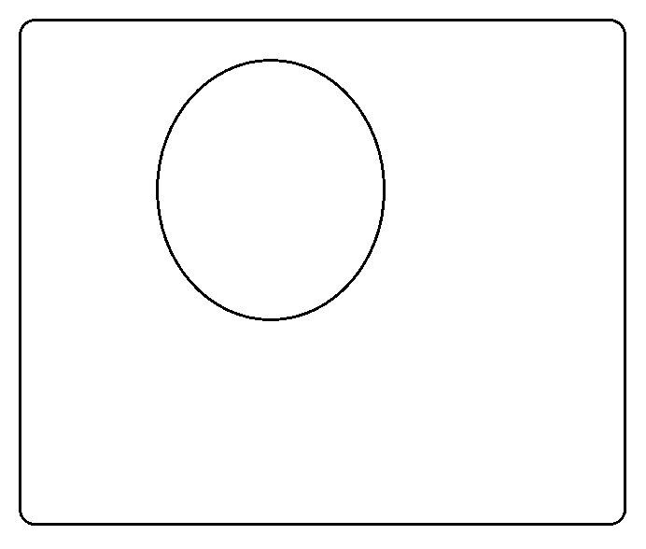

1. Name three things plant cells have that animal cells DO NOT:
2. What would happen if **ribosomes** were eliminated from a cell?
3. What would happen if the **nucleus** were eliminated from a cell?
4. What would happen if the **cell membrane** had holes poked in it?

**Compare and contrast prokaryotic and eukaryotic cells by sorting the words into the correct categories below.**

|  |  |  |
| --- | --- | --- |
| Prokaryotes  **Words to sort:**   * Animal * Bacteria * Cell membrane * Cytoplasm * DNA * Membrane-bound organelles * Mitochondria * No nucleus * Nucleus * Plant * Ribosomes | BOTH | Eukaryotes |
|  |  |  |

**Homeostasis& Cellular Transport**

1. What is **homeostasis**? Which STERNGRR characteristic is it?
2. Color and label the picture of a cell membrane below:

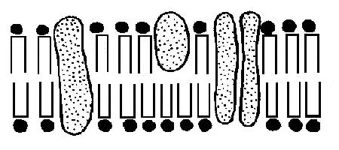

1. Complete the following chart about the characteristics of each type of transport.

|  |  |  |  |  |
| --- | --- | --- | --- | --- |
|  | **Active Transport** | **Passive Transport** | | |
| **Type** |  |  |  | osmosis |
| **Material transported?** | large particles | small particles | large particles |  |
| **Direction?** |  | high to low |  |  |
| **ATP needed?** |  |  |  |  |
| **Protein needed?** |  |  |  |  |

1. Draw an arrow in each of the pictures below to indicate which way **water** will move (osmosis!).

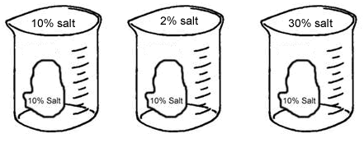

1. A cell with 5% salt concentration is placed in a beaker with a 20% salt concentration. **Osmosis occurs.** Draw a picture to illustrate the scenario. Include an arrow to show which way movement occurs.

1. A cell with 5% salt concentration is placed in a beaker with a 20% salt concentration. **Diffusion occurs.** Draw a picture to illustrate what will happen.
2. A cell with 5 glucose molecules outside and 200 glucose molecules inside needs even MORE glucose inside! **Active transport** occurs. Draw a picture to illustrate what will happen.  
   1. Is there a protein involved with active transport? \_\_\_\_\_
   2. Is energy (ATP) involved with active transport? \_\_\_\_\_

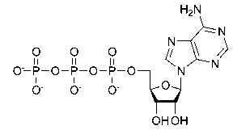

**Bioenergetic Reactions**

**Use the image to the right for the following questions.**

1. How many phosphates (P) are in the molecule to the right? \_\_\_\_
2. What molecule is the energy currency of the cell? \_\_\_\_\_\_\_\_
3. Adenosine triphosphate (ATP) is “recharged” in the mitochondria where which process occurs?

**The pictures below illustrate important bioenergetic reactions. List the reactants and products that are involved.**

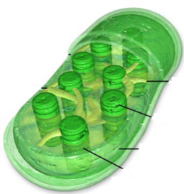

Products:

\_\_\_\_\_\_\_\_\_\_\_(gas)

\_\_\_\_\_\_\_\_\_\_\_\_\_\_\_

Reactants:

\_\_\_\_\_\_\_\_\_\_\_(gas)

\_\_\_\_\_\_\_\_\_\_\_\_\_\_\_

\_\_\_\_\_\_\_\_\_\_\_\_\_\_\_

out

in

1. What process is pictured above?

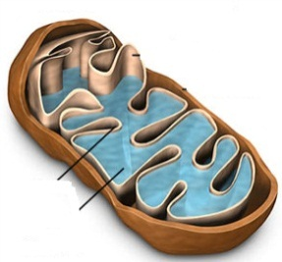

Products:

\_\_\_\_\_\_\_\_\_\_\_(gas)

\_\_\_\_\_\_\_\_\_\_\_\_\_\_\_

\_\_\_\_\_\_\_\_\_\_\_\_\_\_\_

in

Reactants:

\_\_\_\_\_\_\_\_\_\_\_(gas)

\_\_\_\_\_\_\_\_\_\_\_\_\_\_\_

out

1. What process is pictured above?

1. Compare and contrast aerobic and anaerobic respiration using the chart below**:**

|  |  |  |
| --- | --- | --- |
|  | **Aerobic** | **Anaerobic** |
| What does the name mean? |  |  |
| # of ATP produced |  |  |
| Where does it occur? |  |  |
| What are the two types? |  |  |
| What type do humans perform & what does it feel like? |  |  |
| What type is involved with beer and bread? |  |  |

**DNA Structure & Replication**

**Label the parts of the nucleotide below.**

**Parts to label:**

* Phosphate
* Deoxyribose
* Nitrogenous base

1. Adenine always pairs with \_\_\_\_\_\_\_\_\_\_\_\_\_
2. Cytosine always pairs with \_\_\_\_\_\_\_\_\_\_\_\_\_
3. Thymine always pairs with \_\_\_\_\_\_\_\_\_\_\_\_\_\_
4. Guanine always pairs with \_\_\_\_\_\_\_\_\_\_\_\_\_

**Label the following picture using the words in the word bank.**

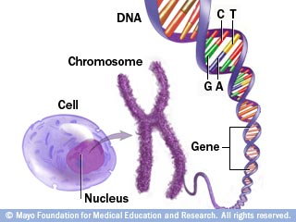

**Parts to label:**

* Cell
* Nucleus
* Chromosome
* DNA
* Gene

1. Why does DNA replicate itself?
2. If you are given the following original strand of DNA, what will be produced after DNA replication? How many DNA molecules are made? Are they identical?:

**original: after replication:**

A – T

T – A

C – G

C – G

C – G

1. What bonds hold together the nitrogenous bases? \_\_\_\_\_\_\_\_\_\_\_\_\_\_\_\_\_\_\_\_\_\_\_
2. What are the 4 main steps of DNA replication? Briefly describe each and show what happens:

|  |  |  |  |
| --- | --- | --- | --- |
| **Step** | **Keyword** | **Description** | **Picture** |
| **1** |  |  |  |
| **2** |  |  |  |
| **3** |  |  |  |
| **4** |  |  |  |

**Mitosis**

1. What are the two main phases of the cell cycle? Label them in the diagram below:

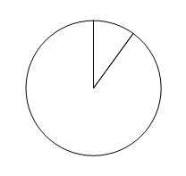

1. Place the following pictures of mitosis in order.

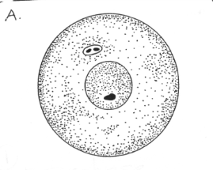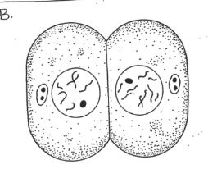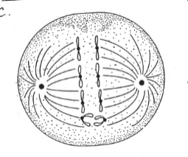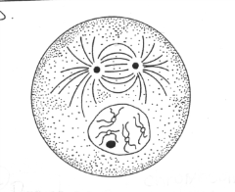

**Steps in order:**

1. \_\_\_
2. \_\_\_
3. \_\_\_
4. \_\_\_
5. \_\_\_
6. \_\_\_

**A B C D**

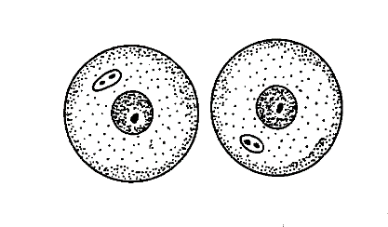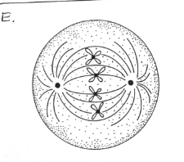

**E F**

1. Define **diploid:**
2. Define **mitosis:**
3. Give the steps of the cell cycle in order below and explain briefly what happens in each

\_\_\_\_\_\_\_\_\_\_\_\_\_\_🡪 \_\_\_\_\_\_\_\_\_\_\_\_\_\_\_\_🡪 \_\_\_\_\_\_\_\_\_\_\_\_\_\_\_🡪 \_\_\_\_\_\_\_\_\_\_\_\_\_\_\_\_ 🡪 \_\_\_\_\_\_\_\_\_\_\_\_\_\_\_\_🡪 \_\_\_\_\_\_\_\_\_\_\_\_\_\_

**Protein Synthesis**

**Word Bank:**

* DNA
* tRNA
* Nucleus
* Transcription
* Translation
* mRNA
* Ribosome
* Cytoplasm
* Amino acid
* Protein (polypeptide)
* Codon
* Anti-codon

1. Using the word bank, label the diagram below.

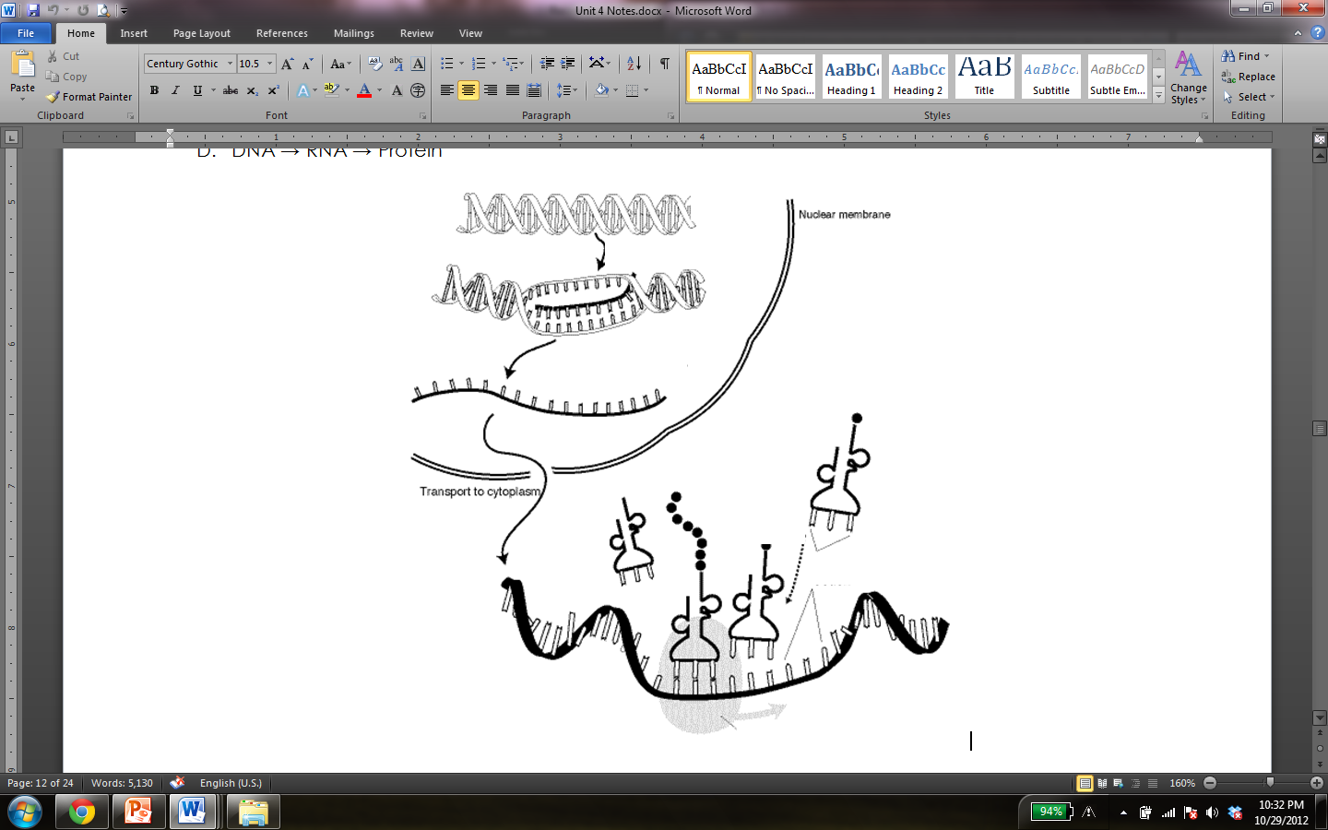

1. What are the two main steps of protein synthesis?
2. Where does translation occur in the cell?
3. Complete the chart below. The first one has been done for you!

|  |  |
| --- | --- |
| **DNA Strand** | **mRNA** |
| TAC GCA | AUG CGU |
| TTA CAT |  |
| TCA ACT |  |
|  | ACU CAG |

1. Use your Codon Chart to identify the amino acids that are coded for by the following codons.

|  |  |  |  |
| --- | --- | --- | --- |
| Codon | Amino Acid | Codon | Amino Acid |
| AUU |  | UGG |  |
| GGA |  | GAA |  |
| AUG |  | GAU |  |
| UCU |  | CCC |  |
| CGC |  | AAC |  |
| UGU |  | CUC |  |

1. Complete the following diagram using your knowledge of transcription and translation**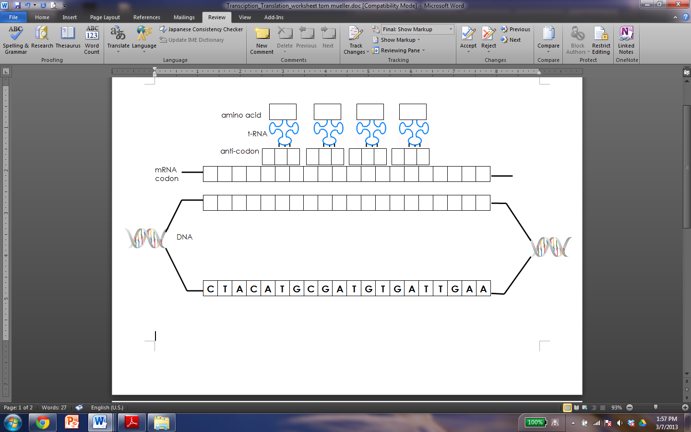**

**Picture Review**

**For the pictures below answer the corresponding questions.**

|  |  |
| --- | --- |
| **Picture** | **Analysis Questions** |
| img1.jpg | Think about the **central dogma** of biology and explain how that concept relates to the image to the left. |
| img2.jpg | What process allows side A and side B to maintain homeostasis?   1. Osmosis 2. Transcription 3. Translation 4. Diffusion |
| img3.jpg | What type of cell is this? How do you know?   1. Plant cell; has a central vacuole 2. Animal cell; has a central vacuole 3. Bacteria cell; it’s small 4. Animal cell; it has a chloroplast |
| img4.jpg | What can be determined from this chart?   1. As the temperature rises so does the rate of the enzyme reaction 2. As the temperature decreases so does the rate of the enzyme reaction 3. The enzyme’s highest rate of reaction is at 30O 4. Stage 2 has the highest rate of reaction |
| img5.jpg | Explain what is happening in this image. Be sure to include the following terms in your explanation: **catalyst, specific, active site, substrate, enzyme-substrate complex, products.** |
| img7.jpg | Label the nucleotide. Word bank: **phosphate, deoxyribose, hydrogen bond, nitrogenous base.**  What is the ratio of adenine to thymine?  What is the ration of cytosine to guanine?  If there are 500 cytosine molecules within a DNA strand, how many guanines are present  What are the steps of DNA replication?  1.  2.  3.  4.  What does semi-conservative mean? |
|  | Based on this representation, what bioenergetic reaction is shown?  Write the equation below:  What type of organisms perform this reaction?  Where does this reaction take place? |
|  | Using the image as a guide, in your own words explain the **carbon cycle** |
|  | This picture demonstrates the process seen during bread and beer making. This process is known as:   1. Lactic acid fermentation 2. Aerobic respiration 3. Alcoholic fermentation 4. Photosynthesis   Based on your answer, write the equation for this process.  \_\_\_\_\_\_\_\_ 🡺\_\_\_\_\_\_\_\_+ \_\_\_\_\_\_\_\_+\_\_\_\_\_\_\_\_\_+ \_\_\_\_\_ |
|  | **Label** each of the organelles listed and describe their **functions.**  J:  K:  L:  M: |
|  | Which step comes after #3?   1. 1 2. 4 3. 5 4. 2 |