Topic 8.1 Population Pyramids & Demographic Transition Model
Population Pyramids (Age-Gender Pyramids)
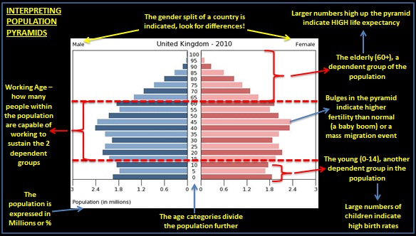

Demographic Transition Model (DTM)
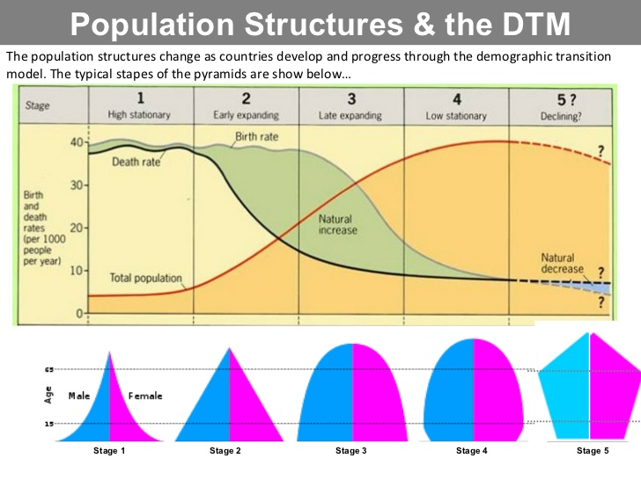
Stage 1: High Stationary (Pre-Industrial)
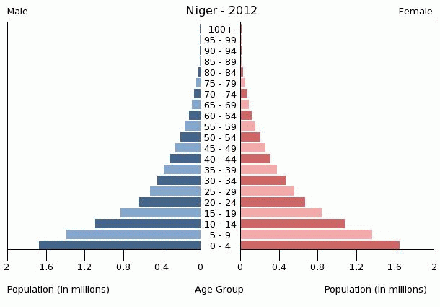

Stage 2: Early Expanding (LEDCs)
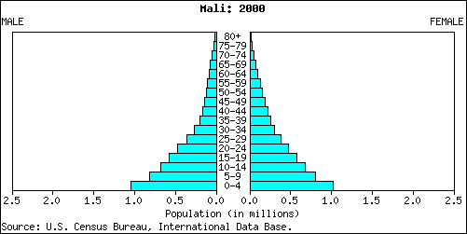

Stage 3: Late Expanding (Wealthier LEDCs)
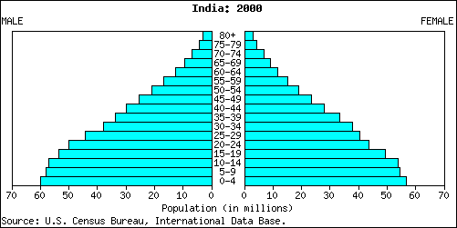

Stage 4: Low Stationary (MEDCs)
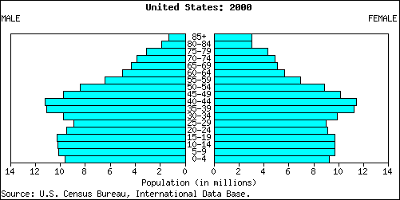

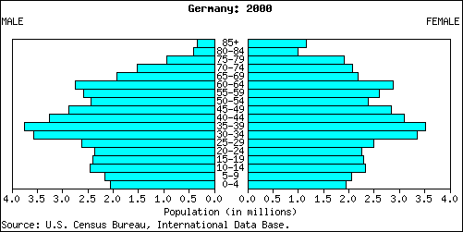
Stage 5: Declining (MEDCs)

