**Unit 1: Scientific Method & What is Biology?**

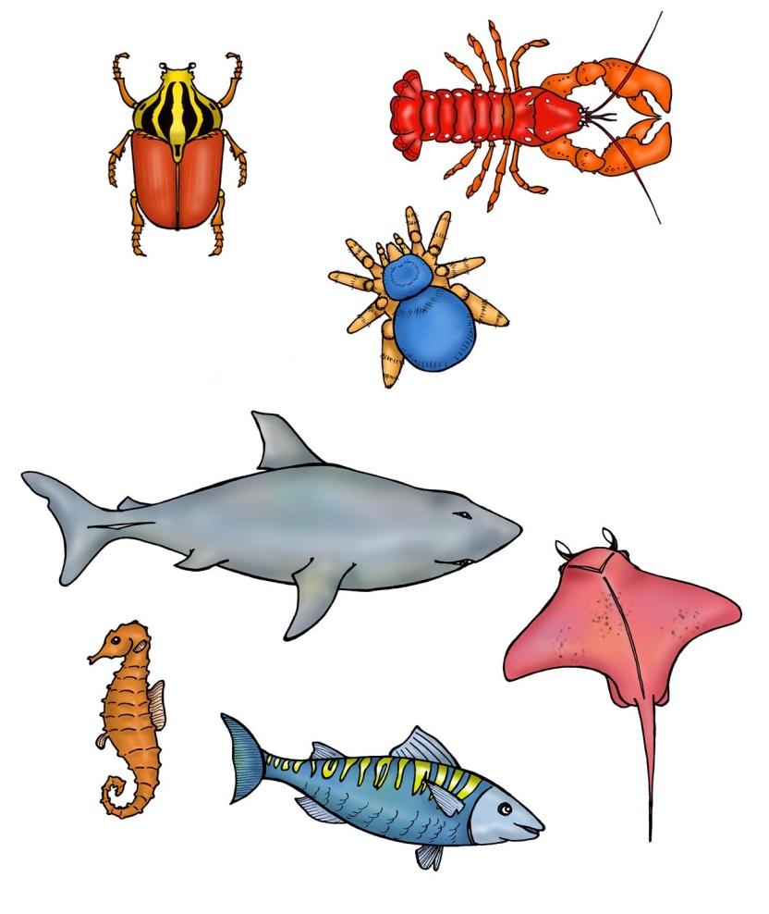

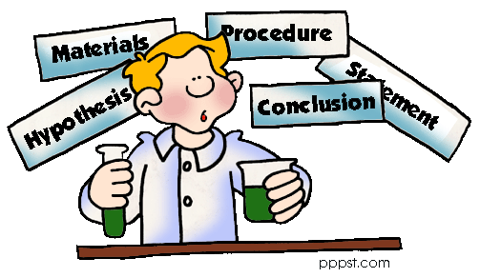

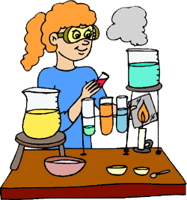

**Key Takeaways:**

* Biology is the study of life.
* Abiotic means non-living.
* Biotic means living.
* STERNGRR can be used to classify something as biotic.

**Unit Vocabulary:**

Choose *at least* 5 words to add to your glossary. Words with an asterisk (\*) are **required**.

* Hypothesis
* Observation
* Inference
* \*Theory
* Control group
* Experimental group
* Dependent variable
* Independent variable
* \*Biotic factor
* \*Abiotic factor

**Unit 1 Quiz:**

**Unit 1 Test:**

**Independent and Dependent Variables**

**U1-2**

|  |  |
| --- | --- |
| CAUSE  **INDEPENDENT VARIABLE** | EFFECT  **DEPENDENT VARIABLE** |
| C:\tempie\Temporary Internet Files\Content.IE5\3V3F1HJR\MC900441468[1].png**The variable that is being \_\_\_\_\_\_\_\_\_\_\_\_\_\_\_\_\_\_\_\_by the scientist or naturally.**  ex. How many hours a student studies  **Examples:**  1) How does sleep affect a student’s test grade?  IV: \_\_\_\_\_\_\_\_\_\_\_\_\_\_\_\_\_\_\_\_\_\_\_\_\_\_\_\_\_\_    2) How does a fatty diet affect a person’s weight?  IV: \_\_\_\_\_\_\_\_\_\_\_\_\_\_\_\_\_\_\_\_\_\_\_\_\_\_\_\_\_\_  3) How does time affect the length of a person’s hair?  IV: \_\_\_\_\_\_\_\_\_\_\_\_\_\_\_\_\_\_\_\_\_\_\_\_\_\_\_\_\_\_ | **The variable that is being \_\_\_\_\_\_\_\_\_\_\_\_\_\_\_\_\_\_\_\_\_\_.**  C:\tempie\Temporary Internet Files\Content.IE5\00XUMV1D\MC900281970[1].wmfex. A student’s test grade  **Examples:**  1) Can Neutrogena face wash decrease acne breakouts?  DV: \_\_\_\_\_\_\_\_\_\_\_\_\_\_\_\_\_\_\_\_\_\_\_\_\_\_\_\_\_  2) Does height affect how far a person can jump?  DV: \_\_\_\_\_\_\_\_\_\_\_\_\_\_\_\_\_\_\_\_\_\_\_\_\_\_\_\_\_  3) How does temperature affect plant growth?  DV: \_\_\_\_\_\_\_\_\_\_\_\_\_\_\_\_\_\_\_\_\_\_\_\_\_\_\_\_\_ |
| **GRAPHING IV & DV:**  **\_\_\_\_\_\_\_\_\_\_\_\_ is (almost) always an independent variable** | |

**PRACTICE!**

**Identify the independent and dependent variable in the examples below:**

1. How does hydration (drinking enough fluids) affect an athlete’s performance?

IV: \_\_\_\_\_\_\_\_\_\_\_\_\_\_\_\_\_\_\_\_\_\_\_\_\_\_\_\_\_\_\_ DV: \_\_\_\_\_\_\_\_\_\_\_\_\_\_\_\_\_\_\_\_\_\_\_\_\_\_\_\_\_\_\_\_\_\_

1. Does playing an instrument improve academic performance?

IV: \_\_\_\_\_\_\_\_\_\_\_\_\_\_\_\_\_\_\_\_\_\_\_\_\_\_\_\_\_\_\_ DV: \_\_\_\_\_\_\_\_\_\_\_\_\_\_\_\_\_\_\_\_\_\_\_\_\_\_\_\_\_\_\_\_\_

1. Does sex education in schools decrease the spread of sexually transmitted diseases?

IV: \_\_\_\_\_\_\_\_\_\_\_\_\_\_\_\_\_\_\_\_\_\_\_\_\_\_\_\_\_\_\_ DV: \_\_\_\_\_\_\_\_\_\_\_\_\_\_\_\_\_\_\_\_\_\_\_\_\_\_\_\_\_\_\_\_\_\_

1. Is there a relationship between socio-economic status and obesity?

IV: \_\_\_\_\_\_\_\_\_\_\_\_\_\_\_\_\_\_\_\_\_\_\_\_\_\_\_\_\_\_\_\_ DV: \_\_\_\_\_\_\_\_\_\_\_\_\_\_\_\_\_\_\_\_\_\_\_\_\_\_\_\_\_\_\_\_\_\_

**Control & Experimental Groups**

**Control group:**

**Experimental group:**

**Graphing**

**U1-3**

|  |  |
| --- | --- |
| **LINE GRAPH**  Function: \_\_\_\_\_\_\_\_\_\_\_\_\_\_\_\_\_\_\_\_\_\_\_\_\_\_\_\_\_\_\_\_\_  http://www.awe.asn.au/branches/sunshine-coast/images/commom_line_graph.jpg | **BAR GRAPH**  Function: \_\_\_\_\_\_\_\_\_\_\_\_\_\_\_\_\_\_\_\_\_\_\_\_\_\_\_\_\_\_\_\_\_\_\_\_\_\_\_\_\_\_  http://image.tutorvista.com/Qimages/QD/5130.gif |
| **PIE GRAPH**  Function: \_\_\_\_\_\_\_\_\_\_\_\_\_\_\_\_\_\_\_\_\_\_\_\_\_\_\_\_\_\_\_\_\_\_  **Pie Graph of Day's Activities** | **SCATTER PLOT**  Function: \_\_\_\_\_\_\_\_\_\_\_\_\_\_\_\_\_\_\_\_\_\_\_\_\_\_\_\_\_\_\_\_\_\_\_\_\_\_\_\_  age_scatterplot |

**PRACTICE!**

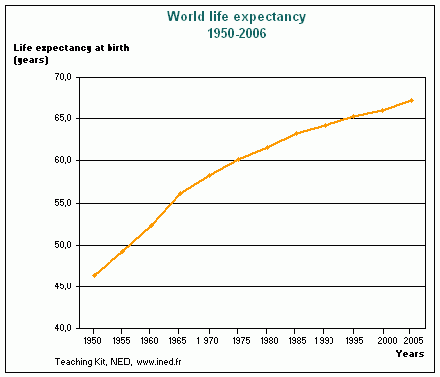

**Use the graph to the right to answer the following questions.**

1. What is the title of the graph?

2. What is the dependent variable? (What is being measured?)

3. What is the independent variable? (What is the scientist changing/what categories is the scientist looking at?)

4. What is happening to the line over time? (Is it increasing? Decreasing? Staying constant?)

**U1-4**

5. What was the life expectancy in 1975?

6. What was the life expectancy in 1980?

7. When was the life expectancy higher, in 1950 or in 1975?

8. When was the life expectancy higher, in 2000 or in 1990?

9. When was the life expectancy higher, in 1957 or in 1978? Explain how you know using a complete sentence with data from the table.

**PRACTICE!**

**Uh oh…the people that did the following experiments forgot to include a control group—they can’t accurately draw conclusions about their experiments! You need to help them be better scientists! Explain what the control group would be for each:**

***Example***: Does drinking Gatorade help you make more layups in basketball? 10 people drink one cup of Gatorade. What should the other group of 10 people do?

|  |  |
| --- | --- |
| **Experimental Group** | **Control Group** |
| http://upload.wikimedia.org/wikipedia/en/thumb/3/3e/GatoradeGlogoconverted.svg/200px-GatoradeGlogoconverted.svg.png  **How many?:** 10 people  **What?:** Drink Gatorade | http://www.clker.com/cliparts/6/d/9/8/1287244981509738217water-droplet-icon.jpg  **How many?:** 10 people  **What?:** Drink water |

1. **Does drinking milk with Vitamin D added make you stronger?**

100 people drink 2 cups of milk with Vitamin D per day for a year and the scientist measures how much weight they can lift. What should the control group be?

|  |  |
| --- | --- |
| **Experimental Group** | **Control Group** |
| **How many?**  *100* people  2 cups  **What?** Milk with Vitamin D | **How many?** \_\_\_ people  \_\_\_ cups  **What?** |

1. **Does singing to plants help them grow taller?**

A person sings to 5 plants for 10 minutes a day. What should the control group be?

|  |  |
| --- | --- |
| **Experimental Group** | **Control Group** |
| **How many?** \_\_\_ plants  \_\_\_ minutes  **What?** Singing | **How many?** \_\_\_ plants  \_\_\_ minutes  **What?** |

1. **Does fertilizer help plants grow taller?**

A scientist adds 5 drops of Fertilizer A to one pot, 5 drops of Fertilizer B to a second pot, and 5 drops of Fertilizer C to a third pot. What should be put in the fourth pot?

**What is Biology?**

**U1-5**

Biology is the study of \_\_\_\_\_\_\_\_\_\_\_!

**Why am I taking this class?**

Biology can enhance your \_\_\_\_\_\_\_\_\_\_\_\_\_\_\_\_\_\_\_\_ of your \_\_\_\_\_\_\_\_\_\_ and the living Earth.

Working \_\_\_\_\_\_\_\_\_\_\_\_\_\_ in this course and passing the \_\_\_\_\_\_\_\_\_\_\_ puts you on the path to graduating from high school and going to college!

**Abiotic/Biotic Inquiry Lab:**

**Objective**: In this activity students will distinguish between abiotic and biotic factors in an ecosystem. They will demonstrate this by identifying and classifying various biotic and abiotic objects.

**Biotic = \_\_\_\_\_\_\_\_\_\_\_\_\_\_\_\_\_**parts of an ecosystem

**Abiotic = \_\_\_\_\_\_\_\_\_\_\_\_\_\_\_\_**parts of an ecosystem

**Directions for the Lab:**

1. At each station you will make 2 observations.

**Use your senses!**

1. You must identify if it should be classified as biotic or abiotic.
2. Then Ms. Simmons will reveal the objects and you will answer analysis questions.

|  |  |  |  |
| --- | --- | --- | --- |
| **Item #** | **Observation 1** | **Observation 2** | **Biotic (B) or Abiotic (A)** |
| **1** |  |  |  |
| **2** |  |  |  |
| **3** |  |  |  |
| **4** |  |  |  |
| **5** |  |  |  |
| **6** |  |  |  |
| **7** |  |  |  |
| **8** |  |  |  |
| **9** |  |  |  |
| **10** |  |  |  |

**U1-6**

|  |
| --- |
| * Whale * Mushroom * Water * Desert * Paper * Glass * Temperature * Coral * Clouds * Snail * Mold * Grass * Hair * Flowers * Ocean * Tree * Rocks * Dirt * Plastic * Grapes * Oxygen |

1. Enter the items from the following list into the Venn diagram below. In the center place items that contain both abiotic and biotic factors.

**Biotic**

**Abiotic**

*All biotic and abiotic factors are interrelated. In nature you will find that if one factor is changed or removed, it impacts the availability of other resources within the ecosystem. Knowing this, give an example of what might happen given the following situations.*

In the open space place either an (**A**) for **abiotic** or a (**B**) for **biotic** to identify the **bolded** object. Then answer the question on the lines provided.

1. All of the **rocks** (\_\_\_) are removed from a desert ecosystem, what would happen to the population of rock dwelling **lizards** (\_\_\_) and the animals that eat the lizards?   
   \_\_\_\_\_\_\_\_\_\_\_\_\_\_\_\_\_\_\_\_\_\_\_\_\_\_\_\_\_\_\_\_\_\_\_\_\_\_\_\_\_\_\_\_\_\_\_\_\_\_\_\_\_\_\_\_\_\_\_\_\_\_\_\_\_\_\_\_\_\_\_\_\_\_\_\_\_\_\_\_\_\_\_\_\_\_\_\_\_\_\_\_\_\_\_\_\_\_\_\_\_\_\_\_\_\_\_\_\_\_\_\_\_\_\_\_\_\_\_\_\_\_\_\_\_\_\_\_\_\_\_\_\_\_\_\_\_\_\_\_\_\_\_\_\_\_\_\_
2. A ten mile area of **trees** (\_\_\_) is removed from the tropical rainforest. How will this affect the amount of **water** (\_\_\_) and the amount of **oxygen** (\_\_\_) in the area?   
   \_\_\_\_\_\_\_\_\_\_\_\_\_\_\_\_\_\_\_\_\_\_\_\_\_\_\_\_\_\_\_\_\_\_\_\_\_\_\_\_\_\_\_\_\_\_\_\_\_\_\_\_\_\_\_\_\_\_\_\_\_\_\_\_\_\_\_\_\_\_\_\_\_\_\_\_\_\_\_\_\_\_\_\_\_\_\_\_\_\_\_\_\_\_\_\_\_\_\_\_\_\_\_\_\_\_\_\_\_\_\_\_\_\_\_\_\_\_\_\_\_\_\_\_\_\_\_\_\_\_\_\_\_\_\_\_\_\_\_\_\_\_\_\_\_\_\_\_

**Analysis Questions:**

1. What is biology?
2. What is the difference between a **biotic** and **abiotic** factor?
3. List **3 biotic** factors that you encounter every day.

Explain why one of these is **biotic**.

1. List **3 abiotic** factors that you encounter every day.

Explain why one of these is **abiotic**.

8 Characteristics of Life

**U1-7**

|  |  |  |
| --- | --- | --- |
|  | **Definition** | **Examples** |
| **S\_\_\_\_\_** |  | Protein synthesis, |
| **T\_\_\_\_\_** |  |  |
| **E\_\_\_\_\_** |  |  |
| **R\_\_\_\_\_** |  |  |
| **N\_\_\_\_\_** |  |  |
| **G\_\_\_\_\_** |  |  |
| **R\_\_\_\_\_** |  |  |
| **R\_\_\_\_\_** |  |  |

**Unit 1 Review**

**U1-9**

**Practice**:

***Identify the IV and DV in the following hypotheses*.**

1. If Ms. Phillips drinks milk every morning, then she will grow tall and strong.   
   IV:  
   DV:
2. If Michael studies for his test, then he will get a high grade.  
   IV:  
   DV:
3. If birds eat rice, then they will explode.  
   IV:  
   DV:

***Read the following experiment and identify its parts***

1. Bart believes that mice exposed to radiowaves will become extra strong (maybe he's been reading too much Radioactive Man). He decides to perform this experiment by placing 10 mice near a radio for 5 hours. He compared these 10 mice to another 10 mice that had not been exposed. His test consisted of a heavy block of wood that blocked the mouse food. he found that 8 out of 10 of the radiowaved mice were able to push the block away. 7 out of 10 of the other mice were able to do the same. Identify the-

**Control Group:**

**Independent Variable:**

**Dependent Variable:**

**What should Bart's conclusion be?:**

**How could Bart's experiment be improved?:**

***Read the following statements and determine which STERNGRR characteristic is described***

How organisms get oxygen and release carbon dioxide to make energy:

How organisms build necessary molecules:

How organisms get what they need to their cells:

How organisms break down and absorb food:

**EOC Questions**

1. When drawing a graph that measures average family income over a period of 50 years, the independent variable  (x axis) is:
2. Income
3. Average
4. Years
5. None of the above

|  |
| --- |
| 1. The graph below shows the relative average mass of the ovaries of a certain species of toad each month for a period of 1 year. Which inference could correctly be made from this graph? 2. imageEggs are produced within the ovaries between May and October. 3. Eggs are released into the environment during the period from November to February. 4. The mating season of this species is from June through November. 5. The toad stops producing eggs in August. |

1. Which statement describes the best procedure to determine if a vaccine for a disease in a certain bird species of effective?
2. Vaccinate 100 birds and expose all 100 to the disease.
3. Vaccinate 100 birds and expose only 50 to the disease.
4. Vaccinate 50 birds, do not vaccinate 50 other birds, and expose all 100 to the disease.
5. Vaccinate 50 birds, do not vaccinate 50 other birds, and expose only the vaccinated birds to the disease.
6. A new drug for the treatment of asthma is tested on 100 people. The people are evenly divided into two groups. One group is given the drug, and the other group is given a glucose pill. The group that is given the glucose pill serves as the
7. experimental group
8. limiting factor
9. control
10. indicator

**U1-10**

1. As part of an investigation, 10 bean seedlings in one setup were grown in the dark, while 10 seedlings in another setup were grown in sunlight.  All other growth conditions were kept the same in both setups.  The seedlings grown in the dark were white with long, slender stems.  The seedlings grown in the sunlight were green and healthy.  Which hypothesis was most likely being tested in this investigation?
2. Plants grown in the dark cannot perform the process of respiration.
3. Sunlight is necessary for the normal growth of bean plants.
4. Light is necessary for the germination of bean seeds.
5. Light is necessary for proper mineral absorption by plants.
6. A study was completed using two groups of 10 plants of the same species. During the study, the plants were placed in identical environmental conditions. The plants in one group were given a growth solution every 3 days. The heights of the plants in both groups were recorded at the beginning of the study and at the end of a 3-week period. The data showed that the plants given the growth solution grew faster than those not given the solution. When other researchers conduct this study to test the accuracy of the results, they should
7. give growth solution to both groups
8. make sure the conditions are identical to those in the first study
9. give an increased amount of light to both groups of plants
10. double the amount of growth solution given to the first group
11. An experiment is being conducted on the following question. Does the color of a shoe increase the visibility of scuff marks shown on it? What is in independent variable?
12. Shoe size
13. Color of the shoe
14. Scuff marks shown
15. Increase
16. If you are graphing the results of an experiment, on which axis would you graph the dependent variable?
17. X axis c. Y axis
18. c. A axis d. Z axis

9. Which life function is primarily involved in converting energy stored in organic molecules into a form directly useable by an organism?

1. Absorption
2. Synthesis
3. Regulation
4. Respiration

10. By which life process does a plant convert food into energy?

a) respiration b) excretion

c) metabolism d) photosynthesis

11. An entire colony (large circle of many cells) appears two days after a single bacteria cell is placed in a petri dish. This life process is:

**U1-11**

1. Organization
2. Reproduction
3. Response to stimulus
4. Energy use

12. The removal of cellular wastes produced from processes like respiration and digestion is which of the following processes?

1. Nutrition c. Transport
2. Excretion d. Regulation

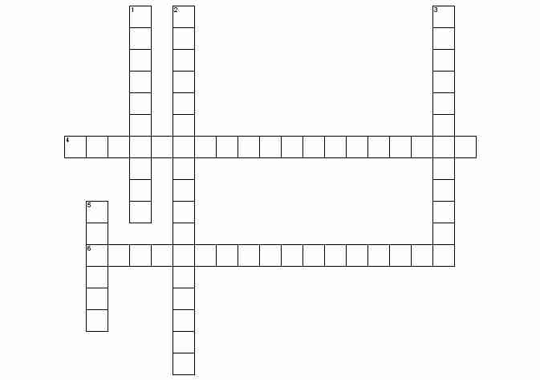

**Unit 1 Crossword Puzzle**

**Across**

|  |  |
| --- | --- |
| 4. | the variable in an experiment that is changed in order to observe some result |
| 6. | the group in an experiment that receives the independent variable, the abnormal condition |

**Down**

|  |  |
| --- | --- |
| 1. | inference or educated guess as to the cause for an observation |
| 2. | the variable in an experiment that is observed as a result of some independent variable |
| 3. | the group in an experiment that does not receive the independent variable, the normal condition |
| 5. | a well established explanation of a natural phenomenon |

**PRACTICE!**

**U1-8**

**Place the following examples of STERNGRR processes in the correct box on the previous page. The first one has been done for you.**

* Protein synthesis
* Anaerobic respiration occurs in cells when there is not enough oxygen
* Fungi decompose dead remains
* Hormones used to communicate and regulate body processes
* Internal or external fertilization
* Nervous system controls bodily processes
* Unicellular organisms are asexual
* Sperm meets an egg
* Sexual reproduction
* Removing unused molecules from food
* Plants exchange gasses through their stomata
* Photosynthesis
* Osmosis
* Anaerobic respiration occurs in cells with no mitochondria
* Animals consume other organisms and absorb food
* Diffusion
* Facilitated Diffusion
* Plants make their own food
* Removing fluids to balance water
* Aerobic respiration occurs in the mitochondria
* Active Transport

**Read the following story about Sammy and answer the question that follows.**

Sammy was a normal, healthy boy. There was nothing in his life to indicate that he was anything different from anyone else. When he completed high school, he obtained a job in a factory, operating a machine press. On this job he had an accident and lost his hand. It was replaced with an artificial hand that looked and operated almost like a real one. Soon afterward, Sammy developed a severe intestinal difficulty, and a large portion of his lower intestine had to be removed. It was replaced with an elastic silicon tube.

Everything looked good for Sammy until he was involved in a serious car accident. Both of his legs and his good arm were crushed and had to be amputated. He also lost an ear. Artificial legs enabled Sammy to walk again, and an artificial arm replaced the real arm. Plastic surgery enabled doctors to rebuild the ear. Over the next several years, Sammy was plagued with internal disorders. First, he had to have an operation to remove his aorta and replace it with a synthetic vessel. Next, he developed a kidney malfunction, and the only way he could survive was to use a kidney dialysis machine (no donor was found for a kidney transplant). Later, his digestive system became cancerous and was removed. He received nourishment intravenously. Finally, his heart failed. Luckily for Sammy, a donor heart was available, and he had a heart transplant.

It was now obvious that Sammy had become a medical phenomenon. He had artificial limbs, nourishment was supplied to him through his veins; therefore he had no solid wastes. All waste material was removed by the kidney dialysis machine. The heart that pumped his blood to carry oxygen and food to his cells was not his original heart. But Sammy's transplanted heart began to fail. He was immediately placed on a heart-lung machine. This supplied oxygen and removed carbon dioxide from his blood, and it circulated blood through his body.

The doctors consulted bioengineers about Sammy. Because almost all of his life-sustaining functions were being carried on by machine, it might be possible to compress all of these machines into one mobile unit, which would be controlled by electrical impulses from Sammy's brain. This unit would be equipped with mechanical arms to enable him to perform manipulative tasks. A mechanism to create a flow of air over his vocal cords might enable him to speak. To do all this, they would have to amputate at the neck and attach his head to the machine, which would then supply all nutrients to his brain. Sammy consented, and the operation was successfully performed.

Sammy functioned well for a few years. However, a slow deterioration of his brain cells was observed and was diagnosed as terminal. So the medical team that had developed around Sammy began to program his brain. A miniature computer was developed: it could be housed in a machine that was humanlike in appearance, movement, and mannerisms. As the computer was installed, Sammy's brain cells completely deteriorated. Sammy was once again able to leave the hospital with complete assurance that he would not return with biological illness.

1. Is Sammy “living” at the end of the story? Why or why not? At what point did you decide that Sammy was no longer “alive”?