Unit 3: Cells, Transport, Photosynthesis & Cellular Respiration Review Stations
Station 1: Basic Cells
Organize the Levels of Cell Organization from SMALLEST to LARGEST:
Tissues organisms cells organ systems organs
1. ________ 2. _________ 3. __________ 4. __________ 5. _____________
A group of cells with the same function is a _______________
A group of tissues combine to form an _________________
2) Magnification: Calculate the LOWEST magnification: _____________
Calculate the HIGEST magnification: ______________

3) A student examines a cell under the microscope and determines that it is a eukaryote. List two structures the student identified in order to come to this conclusion.

4) The whole point of a cell is to make ____________
5) PRO= _____

Station 2: Cell Organelles
1. Sketch a plant cell and an animal cell. Label the following organelles in each of your sketches above: nucleus, ribosome, cell membrane, cell wall, cytoplasm, DNA, mitochondria, vacuoles

3.

4. What is the function of
Ribosomes:
Cell wall:
Nucleus:
Vacuole:
Golgi body:
Endoplasmic reticulum:
Station 4: Cell Communication
1.

2.

3.

Station 3: Cell Specialization
1.

2.
3.
4.
Station 5: Cell Membrane
1. 4.
2. 5.
3. Label the cell membrane:

Station 6: Transport
1.
2.
3.

4. Fill out letters A through D.
Transport | Direction | Energy? | Protein?
 | Particles from High to Low | NO | NO
 | Particles from Low to High | YES | YES
 | Particles from High to Low | NO | YES
 | Water from High to Low | NO | NO

Station 7: Diffusion & Transport Practice
Label the following pictures as Diffusion, Osmosis, Facilitated Diffusion, or Active Transport. Then show which direction the materials will move!
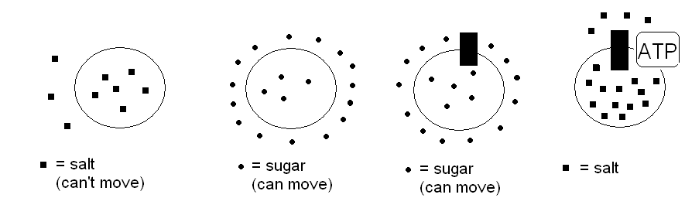
Shrink or Swell?
- Water moves IN? __________________
- Water moves OUT? ________________

Make a prediction
1.

2.

Station 8: Photosynthesis
1.
2.
3.
4.

Station 9: Cell Respiration
1.
2.
3.
4.
5.

Station 10: Aerobic vs. Anaerobic Respiration
1.
2.
3.
4.
5.
6.
7.

Station 11: Practice Questions
1.
2.
3.

Station 12: Practice Questions
1.
2.
3.

Station 13: Practice Questions
1.
2.
3.

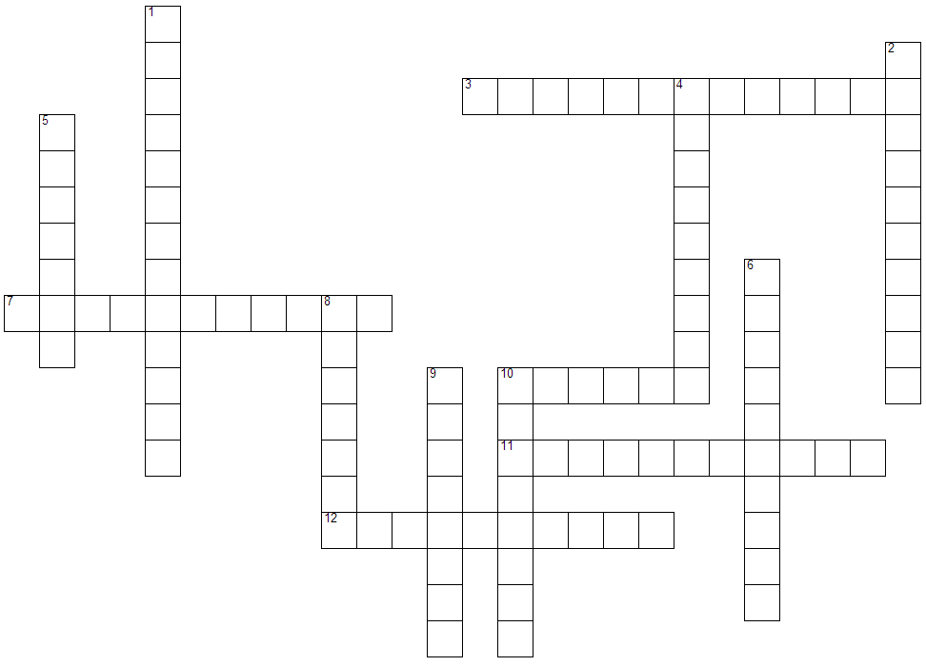
Unit 3 Crossword Puzzle
Across:  3. describes an organism that is composed of more than one cell  7. describes an organism that is composed of only one cell.  10. something that gets dissolved in another substance  11. when the amount of solutes on both sides of the membrane are the same.  12. a byproduct of fermentation that causes muscle fatigue and soreness | Down:  1. describes something that allows some things to pass through but not others.  2. structures within a cell made from molecules that perform a particular task  4. cells that contain a nucleus, membrane bound organelles, and chromosomal DNA  5. a chemical that travels through the blood and allows cells to communicate.  6. a single-celled organism lacking a nucleus, any membrane bound organelles, and has circular DNA  8. a byproduct of fermentation by yeast  9. a mixture of two or more substances where one is dissolved in the other.  10. a cell that has no special job; a cell that has not yet differentiated.

