**STATION 1:**

**BASIC CELLS**

1. *Organize the Levels of Cell Organization from SMALLEST to LARGEST:*

**Tissues organisms cells organ systems organs**

1. ________ 🡪 2. _________ 🡪 3. __________ 🡪 4. __________ 🡪 5. _____________

A group of cells with the same function is a _______________

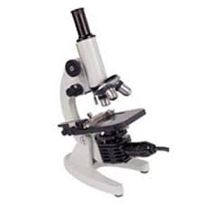A group of tissues combine to form an _________________

**10x**

1. *Magnification:*

**20x**

1. Calculate the **lowest** magnification: ______x

2. Calculate the **highest** magnification: ______x

**10x**

1. A student examines a cell under the microscope and determines that it is a eukaryote. List two structures the student identified in order to come to this conclusion.
2. The whole point of a cell is to make ____________
3. PRO= _____

**STATION 2:**

**CELL ORGANELLES**

1. Sketch a plant cell and an animal cell.
2. Label the following organelles in each: *nucleus, ribosome, cell membrane, cell wall, cytoplasm, DNA, mitochondria, vacuoles*
3. Name 3 things found ONLY in plant cells.
4. What is the function of…

* Ribosomes?
* Cell wall?
* Nucleus?
* Vacuole?
* Golgi body?
* Endoplasmic reticulum?

**STATION 3:**

**CELL SPECIALIZATION**

1. ***Copy this statement:*** All cells in an organism have the SAME DNA, but the DNA tells the cells what jobs to do!
2. Name 2 specialized animal cells:
3. Why do muscle cells and sperm cells have more mitochondria than other cells?
4. How do all cells in your body start off? (hint: two words!)

**STATION 4:**

**CELL COMMUNICATION**

1. Name the two ways cells communicate:
2. Draw a hormone and receptor protein:
3. Name two ways that neurons and hormones are different, and one way they are similar!

**STATION 5:**

**CELL MEMBRANE**

1. What is the job of the cell membrane?
2. What is homeostasis? Give an example!
3. Label the cell membrane:

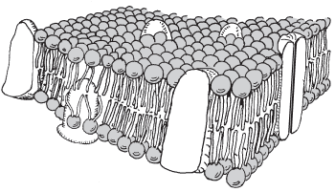 y_________

X_________

1. What can NOT cross the cell membrane freely?
2. Draw a concentration gradient. Label the HIGH and LOW concentrations.

**STATION 6:**

**TRANSPORT**

1. How are active and passive transport different?
2. How are diffusion and osmosis different?
3. Draw a picture of “equilibrium”
4. Fill out the following chart:

|  |  |  |  |
| --- | --- | --- | --- |
| **Transport** | **Direction** | **Energy?** | **Protein?** |
|  | Particles from High to Low | NO | NO |
|  | Particles from Low to High | YES | YES |
|  | Particles from High to Low | NO | YES |
|  | Water from High to Low | NO | NO |

**STATION 7:**

**PRACTICE with TRANSPORT**

**Sketch and label the following pictures as:**

Diffusion, Osmosis, Facilitated Diffusion, or Active Transport

**Then show which direction the materials will move!**

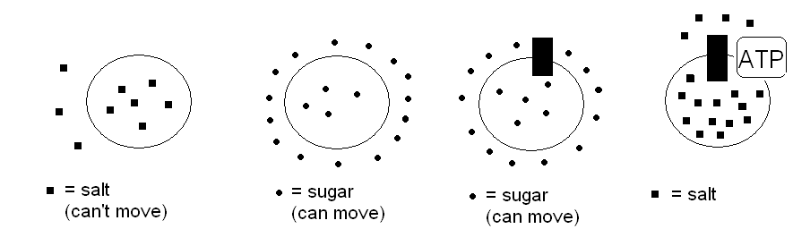

**Shrink or Swell?**

1. Water moves IN? __________________
2. Water moves OUT? ________________

**Make a Prediction:**

1. You put a saltwater fish into a tank of distilled water. Draw a picture and explain!
2. You put a cell into salt water. Draw a picture and explain!

**STATION 8:**

**PHOTOSYNTHESIS**

1. In what organelle does photosynthesis take place?
2. What are the REACTANTS of photosynthesis?
3. What are the PRODUCTS of photosynthesis?
4. What is the difference between an autotroph and a heterotroph?

**STATION 9:**

**CELLULAR RESPIRATION**

1. In what organelle does respiration take place?
2. What are the REACTANTS of respiration?
3. What are the PRODUCTS of respiration?
4. Who does respiration?
5. What does respiration make that your body needs?

**STATION 10:**

**AEROBIC versus ANAEROBIC**

1. How many phosphates does ATP have?
2. How many phosphates does ADP have?
3. Which molecule represents the “FULL” battery?
4. What does “Anaerobic” mean?
5. Describe lactic acid fermentation: Where does it happen?
6. Describe alcoholic fermentation: What organism does this?
7. Which type of respiration gives you the most ATP?

**STATION 11:**

**Practice Questions**

1. Which structures are found in every living cell?
2. A cell membrane and cytoplasm
3. Chloroplasts and mitochondria
4. A cell wall and nucleus
5. Centrioles and chromosomes
6. What is the biggest difference between a bacterial cell and a plant cell?
7. A bacterial cell has mitochondria, plants do not
8. A plant cell has a nucleus, the bacteria cell does not
9. A bacterial cell has no cell membrane, a plant cell has a cell wall
10. A plant cell has no ribosomes, the bacterial cell does
11. What do neurons and hormones have in common?
12. They both travel quickly throughout an organism’s cells
13. They are both used for protein synthesis
14. They are both forms of cell communication
15. They are both examples of enzyme proteins

**STATION 12:**

**Practice Questions**

1. A biologist observed a plant cell in a drop of water as shown in the diagram A below. The biologist added a 10% salt solution to the slide and observed the cell as shown in diagram B.

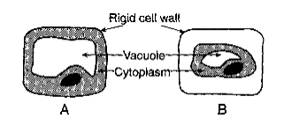

The change in appearance of the cell resulted from

1. More salt moving out of the cell than into the cell
2. More salt moving into the cell than out of the cell
3. More water moving into the cell than out of the cell
4. More water moving out of the cell than into the cell
5. Maintenance of pH in human blood at a certain level is an example of
6. Digestion
7. Synthesis
8. Respiration
9. Homeostasis
10. A red blood cell placed in distilled water will swell and burst due to the diffusion of
11. Salt from the red blood cell into the water
12. Water into the red blood cell
13. Water from the blood cell into its environment
14. Salt from the water into the red blood cell

**STATION 13:**

**Practice Questions**

1. Which letters represent substances needed by the plant to carry out photosynthesis?

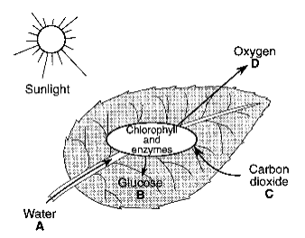

1. A and C
2. B and C
3. C and D
4. B and D

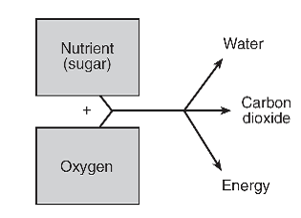

1. Cells usually transfer the energy that is released directly to
2. Glucose
3. ATP
4. Oxygen
5. Enzymes
6. Which substance is needed for aerobic cellular respiration to occur?
7. Carbon dioxide
8. Oxygen
9. Glucose
10. Methane